Institute Of technology carlow
Design Manual
Match Tracker Mobile Application
Laura O’Callaghan Conlon
1/10/2014

This document will describe in detail the various aspects of the system that is being developed. It will detail various tools, protocols and designs of the system components as well as providing diagrams to illustrate the finer points of the system and also give a high level view of the project.

Table of Contents
1. Introduction 1
1.1. Purpose and Content 1
1.2. Use Case Diagram 1
2. Methodology, Tools and Techniques 2
2.1. PhoneGap 2
2.2. Sublime Text 2
2.3. Google App Engine 2
3. Communication Protocols 2
3.1. Mobile to Cloud 2
3.2. Website to Cloud 2
4. Cloud Database 2
4.1. Details 2
4.2. Design 2
5. Domain Model 2
6. GUI 2
6.1. Mobile 2
6.2. Website 2

- Introduction
  - Purpose and Content
The purpose of this design document is to provide details for how the Match Tracker system should be built. Included in this document are use cases, use case diagram, general architecture design specifications, narrative descriptions of the software design and samples of the application GUI. The details included in this document should provide a description of the system that is complete enough to allow any developers to be able to understand how this system is to be built.
Also outlined in this document are the various tools that will be used to build and develop the mobile, cloud and web sections of the project. Communication protocols and database designs are also included.
  - Use Case Diagram
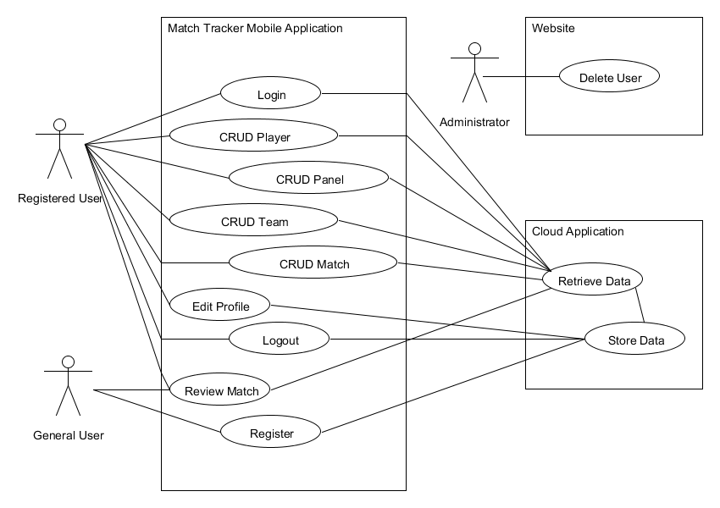
- Methodology, Tools and Techniques
  - PhoneGap
PhoneGap is an open source framework for quickly building cross-platform mobile apps using HTML5, Javascript and CSS. It was initially investigated as an option for building this application as the results of previous surveys suggested that the prospective user base was a 50/50 split between iPhone and Android devices. Later on in the project, PhoneGap was rejected as an option for this system due to the hardware and software constraints on development.
  - Google App Engine
Google App Engine is a Platform as a Service (PaaS) offering that lets you build and run applications on Google’s infrastructure. App Engine applications are easy to build, easy to maintain, and easy to scale as your traffic and data storage needs change. With App Engine, there are no servers for you to maintain. You simply upload your application and it’s ready to go.
  - XAMPP
XAMPP is a completely free, easy to install Apache distribution containing MySQL, PHP, and Perl. The XAMPP open source package has been set up to be incredibly easy to install and to use.
  - IntelliJ IDEA
IntelliJ is a powerful IDE for Java Platform although it is made to be used with a host of technologies. Simplified web development with intelligent editors for HTML, JavaScript, CSS and other languages and technologies such as Sass, LESS, TypeScript, CoffeeScript, Node.js. Extensive support for PHP, Ruby on Rails and Python/Django.
- Database
  - Details
This project uses MySQL database system which is connected to and manipulated by PHP code. MySQL was chosen for this project because it is a database system that is widely used on the web, running on a server. It is capable of handling small and large applications quickly and reliably. It is also free to download and use.
The database for this system comprises a user database for storing all registered user information, a fixtures database for storing all match related data and finally a player database for all player details that have been registered.
  - Design

Fixture Database
fixture_database
This table holds the individual fixture records and all associated data
Attribute | Description |  |  | Type |  |  |  | Examples of Values
competition | The competition name |  |  | varchar(50) |  |  |  | Paul Flood Cup, Paul Cusack Plate
home_team | The home team name |  |  | varchar(50) |  |  |  | Athy, Carlow, Naas
away_team | The away team name |  |  | varchar(50) |  |  |  | Tullow, Wexford, CYM
venue | The venue where the match is played |  |  | varchar(50) |  |  |  | Athy RFC, Carlow RFC, Kilkenny RFC
fixture_date | The date that the match is played |  |  | date |  |  |  | 01/02/2014
home_score | The total score for the home team |  |  | int |  |  |  | 1 to 100
away_score | The total score for the away team |  |  | int |  |  |  | 1 to 100
home_trys | The total number of trys for the home team |  |  | int |  |  |  | 1 to 100
away_trys | The total number of trys for the away team |  |  | int |  |  |  | 1 to 100
home_conversions | The total number of conversions for the home team |  |  | int |  |  |  | 1 to 100
away_conversions | The total number of conversions for the away team |  |  | int |  |  |  | 1 to 100
home_penalties | The total number of penalties for the home team |  |  | int |  |  |  | 1 to 100
away _penalties | The total number of penalties for the away team |  |  | int |  |  |  | 1 to 100
home_drop_goal | The number of drop goals for the home team |  |  | int |  |  |  | 1 to 100
away_drop_goal | The number of drop goals for the away team |  |  | int |  |  |  | 1 to 100
home_red_card | The number of red cards given to the home team |  |  | int |  |  |  | 1 to 15
away_red_card | The total number of red cards given to the away team |  |  | int |  |  |  | 1 to 15
home_yellow_card | The total number of yellow cards given to the home team |  |  | int |  |  |  | 1 to 15
away_yellow_card | The total number of yellow cards given to the away team |  |  | int |  |  |  | 1 to 15
scrums_contested | Value of 1 indicates the scrums were contested |  |  | tinyint |  |  |  | 0 or 1
scrums_contested | Value of 1 indicates the scrums were contested |  |  | tinyint |  |  |  | 0 or 1
uncontested_request | Which team requested the scrums to be uncontested |  |  | varchar(50) |  |  |  | Carlow, CYM, Tallaght

User Database
user_database
This table holds the individual user records and all associated data
Attribute | Description |  |  | Type |  |  |  | Examples of Values
f_name | The users first name |  |  | varchar(255) |  |  |  | Amy, Laura, Dave
l_name | The users last name |  |  | varchar(255) |  |  |  | Stafford, Conlon, McGrath
email | The users email address |  |  | varchar(255) |  |  |  | lauraocalcon@gmail.com
club_name | The name of the club the user is working with |  |  | varchar(255) |  |  |  | Athy RFC, Carlow RFC, Malahide RFC
user_role | The role of the user within their club |  |  | varchar(255) |  |  |  | Head Coach, Backs Coach, Assistant Coach
user_password | The user password for their accound |  |  | varchar |  |  |  | password123, abc123

Player Database
player_database
This table holds the individual player records and all associated data
Attribute | Description |  |  | Type |  |  |  | Examples of Values
player_pin | Pin number for the player issued by the IRFU |  |  | int |  |  |  | 1 to 250000
f_name | The users first name |  |  | varchar(255) |  |  |  | Amy, Laura, Dave
l_name | The users last name |  |  | varchar(255) |  |  |  | Stafford, Conlon, McGrath
primary_club | The primary club the player is registered with |  |  | varchar(255) |  |  |  | Athy RFC, Carlow RFC
primary_team | The primary team the player is registered to |  |  | varchar(255) |  |  |  | Senior Ladies First XV, U18 Junior Girls, Senior Men Second XV

- Use Cases
  - Register
Name: Register
Actors: General User
Description: When a user wishes to sign up to the system they must first register. They do this by submitting their name, email, password and cub name into a form that is displayed on the Login screen. The user then clicks the submit button and their information is stored in the user database.
  - Login
Name: Login
Actors: Registered User
Description: When a user wishes to use the Match Tracker system they must first log in to the webpage or mobile application to access the features of the system. To achieve this, the user must input username and a password, as set up on registration. This information is checked against the entries in the User Database and if correct, the user’s session is started and they are redirected to the Home/Main Menu screen.
  - Create Player
Name: CreatePlayer
Actors: Registered User
Description: When the user wishes to create a new player they must select the Create New Player option from the Player Menu which is found in the Main Menu. This will allow the user to enter data about the new player, each player must have a first and last name and a registration number. This information is entered into text boxes in the form of strings and integers. Once the user has entered the required information they may then submit this record which will be stored in the Player Database. The user will be alerted that the player profile has saved correctly when the record is submitted.
  - Edit Player
Name: EditPlayer
Actors: Registered User
Description: When the user wishes to edit an existing player record they may do so by selecting the Edit Player option in the Player Menu which is found in the Main Menu. This will display to the user an option to search for a player by name. Once the user has entered a name, a list of all matching players will be displayed on the screen. The user may then select a player from this list and the details for same will be displayed on the screen, these details may then be edited from here. When the user is satisfied with the changes made they may submit the updated record for submission. The user will be alerted that the player profile has been updated.
  - Delete Player
Name: DeletePlayer
Actors: Registered User
Description: When the user wishes to delete an existing player record they may do so by selecting the Delete Player option in the Player Menu which is found in the Main Menu. This will display to the user an option to search for a player by name. Once the user has entered a name, a list of all matching players will be displayed on the screen. The user may then select a player from this list and the details for same will be displayed on the screen, the player may then be deleted from here, once they have verified that it is the correct player by checking the player details. The user will be asked to confirm deletion, once the user has confirmed same the player record will be deleted.
  - Create Panel
Name: CreatePanel
Actors: Registered User
Description: When a user wishes to create a new panel of players they may do so by selecting the Create New Panel option from the Panel Menu which is found in the Main Menu. When selected, this option displays the Create New Panel screen. On this screen the user must enter a name for the new panel then they may select any number of players from the full list of players stored in the Player Database which will be displayed on the screen. When all required players have been selected using checkboxes, the user may then select to add these players to the new panel. When the user is satisfied with the selected players they then may save that panel. The player records are updated in the Player Database to add the new panel ID to their individual records.
  - Edit Panel
Name: EditPanel
Actors: Registered User
Description: When a user wishes to edit an existing panel of players they may do so by selecting the Edit Panel option from the Panel Menu which is found in the Main Menu. When selected, this option displays the Edit Panel screen. This screen will display a dropdown menu from which the user can select the panel they wish to edit. Once the panel is selected the list of players contained in same will be displayed on the screen for the user to edit along with the full list of players in the Player Database. If the user wishes to add a player to the panel this may be done by selecting any number of players from the full list of players in the Player Database. When all required players have been selected using checkboxes, the user may then select to add these players to the existing panel. If the user wishes to remove a player from the panel this may be done by selecting the players from the panel using checkboxes. When the user is satisfied that all required players are selected for deletion they may then select the delete option and those selected players will be removed from the panel. The player records will be updated in the Player Database to either add panel ID to, or remove panel ID from, their individual records.
  - Delete Panel
Name: DeletePanel
Actors: Registered User
Description: When a user wishes to delete a new panel of players they may do so by selecting the Delete Panel option from the Panel Menu which is found in the Main Menu. When selected, this option displays the Delete Panel screen. This screen will display a dropdown menu from which the user can select the panel they wish to delete. The chosen panel will then be displayed on the screen. When the user is sure this is the correct panel they may then select to delete the panel. The user will be asked to confirm deletion, once confirmation has been made the panel will then be deleted from the database and the panel ID will be removed from all associated player profiles.
  - Create Team
Name: CreateTeam
Actors: Registered User
Description: When a user wishes to create a new team of players they may do so by selecting the Create New Team option from the Team Menu which is found in the Main Menu. When selected, this option displays the Create New Team screen. On this screen the user must first select a panel to choose players from then the user must enter a name for the new Team, then they may select a minimum of 15 and maximum of 22 players from the list of players which have previously been stored in the Player Database under a certain panel which was chosen previously and will be displayed on the screen. When all required players have been selected using checkboxes, the user may then select to add these players to the new team. When the user is satisfied with the selected players they then may drag and drop players within the new team list in order to place the players in the correct positions, the user may then save that team. The player records are updated in the Player Database to add the new panel ID to their individual records.
  - Edit Team
Name: EditTeam
Actors: Registered User
Description: When a user wishes to edit an existing team of players they may do so by selecting the Edit Team option from the Team Menu which is found in the Main Menu. When selected, this option displays the Edit Team screen. This screen will display a dropdown menu from which the user can select the Team they wish to edit. Once the Team is selected the list of players contained in same will be displayed on the screen for the user to edit along with the full list of players from the chosen panel. If the user wishes to add a player to the team this may be done by selecting any number of players from the full list of players in the chosen panel. When all required players have been selected using checkboxes, the user may then select to add these players to the existing team. If the user wishes to remove a player from the team this may be done by selecting the players from the team using checkboxes. When the user is satisfied that all required players are selected for deletion they may then select the delete option and those selected players will be removed from the team. Players may also be dragged and dropped from position to position in order to alter the team. The player records will be updated in the Player Database to either add team ID to, or remove team ID from, their individual records as well as changing the players current position.
  - Delete Team
Name: DeleteTeam
Actors: Registered User
Description: When a user wishes to delete a team of players they may do so by selecting the Delete Team option from the Team Menu which is found in the Main Menu. When selected, this option displays the Delete Team screen. This screen will display a dropdown menu from which the user can select the team they wish to delete. The chosen team will then be displayed on the screen. When the user is sure this is the correct team they may then select to delete the team. The user will be asked to confirm deletion, once confirmation has been made the team will then be deleted from the database and the team ID will be removed from all associated player profiles.
  - CRUD Match
Name: CRUDMatch
Actors: Registered User
Description: When a user wishes to create or edit a match they may do so by selecting either of these options from the Match Menu which is found in the Main Menu. When selected, these options display either the Create Match screen or the Edit Match screen depending on user selection. The Create Match screen allows the user to enter details of the match such as teams involved, location, date, time and competition. Once the user has entered all these details they may then save that match so that it may be tracked at a later date. If the user has selected to edit a match the screen that is displayed requires the user to select a previously created match from a drop down box containing the list of existing matches. Once the user has selected a match the details of same are then displayed on the screen in text boxes where they may be edited by the user. When the user is satisfied that all information is correct they may save this match. The match database is then updated with the relevant information which may then be displayed to other users.
  - Track Match
Name: TrackMatch
Actors: Registered User
Description: When the user wishes to track the details of a match they may do so by selecting this option from the Match Menu which is found in the Main Menu. On selection the user is presented with the Track Match screen which requires the user to enter various details about the match that has been played. The details include final score, tries scored, conversions scored, penalty kicks scored, drop goals scored, yellow cards, red cards and if scrums were contested or not. On entering this information the user may then save the details relating to the match played. The match database is updated with this information which may then be displayed to other users.
  - Review Match
Name: ReviewMatch
Actors: General User
Description: If a user wished to review the results of a previously played match they may do so by accessing the Review Match page on the website or in the mobile application. The user does not have to be registered or logged in to access this page. The user may select the match they wish to review by selecting from a list of all recorded matches which will be displayed on the initial Review Match screen. Once the user has made their selection the details of same will be displayed on screen.
  - Delete User
Name: DeleteUser
Actors: Administrator
Description: When a user profile needs to be deleted this may be done by an administrator, by accessing the list of user profiles from the User Database. The administrator may then mark the chosen user for deletion, following which the record will be removed from the User Database.
  - Edit User Profile
Name: EditProfile
Actors: Registered User
Description: When a registered user wishes edit their own profile they may select this option from the Main Menu. Once selected, the Edit Profile screen will be displayed to the user. From this screen the user may view and edit their personal profile details. The user may change their name, email address, club name or password. They may also upload or change a previously uploaded profile picture. Once the user is satisfied with the changes they have made they may save this as their new updated profile.
  - Logout
Name: Logout
Actors: Registered User
Description: When the user wishes to logout they may do so from anywhere in the system by selecting the logout option which appear on every screen of the system. When the user selects this option they will be asked to confirm that they want to log out, if the user has a Create or Edit session open then they will be asked if they wish to save their progress in that session before logging out. When the user confirms that they want to log out their session will be ended and they will be redirected back to the login screen.
- Detailed Use Cases
  - CRUD Fixture
Name: CRUDFixture
Actors: Registered User
Brief Description: When a user wishes to create or edit a match they may do so by selecting either of these options from the Match Menu which is found in the Main Menu. When selected, these options display either the Create Match screen or the Edit Match screen depending on user selection. The Create Match screen allows the user to enter details of the match such as teams involved, location, date, time and competition. Once the user has entered all these details they may then save that match so that it may be tracked at a later date. If the user has selected to edit a match the screen that is displayed requires the user to select a previously created match from a drop down box containing the list of existing matches. Once the user has selected a match the details of same are then displayed on the screen in text boxes where they may be edited by the user. When the user is satisfied that all information is correct they may save this match. The match database is then updated with the relevant information which may then be displayed to other users.
Main Success Scenario:
  - The user obtains all details of fixture to be created
  - The user choses the option to create a new fixture from the Game Menu of the application
  - The application displays the create fixture screen with all text boxes empty
  - The user fills in all the details of the fixture (competition name, home team name, away team name, venue and date of fixture)
  - The user submits the information to the application
  - The application verifies the information entered
  - The application stores the information in the database
  - The user leaves the application
Alternatives
2a. The user wishes to edit a fixture
    - The user choses the option to edit a fixture from the Game Menu of the application
    - The application displays the initial screen of the edit fixture option
    - The user is required to select a date of the fixture they wish to edit by selecting from a dropdown list of all previously created fixtures
    - The user submits date selection
    - The application displays the details of the selected fixture
    - The user may now edit any fields of the fixture except for the date
    - The user may then save changes
    - The updated fixture is displayed to the user for confirmation
    - The user exits the edit fixture screen

  - Track Match
Name: TrackMatch
Actors: Registered User
Brief Description: When the user wishes to track the details of a match they may do so by selecting this option from the Match Menu which is found in the Main Menu. On selection the user is presented with the Track Match screen which requires the user to enter various details about the match that has been played. The details include final score, tries scored, conversions scored, penalty kicks scored, drop goals scored, yellow cards, red cards and if scrums were contested or not. On entering this information the user may then save the details relating to the match played. The match database is updated with this information which may then be displayed to other users.
Main Success Scenario:
  - A match has been played and the final results are known to the user
  - The user selects the track match option from the Game Menu
  - The user must then select a fixture by date, from a drop down menu of all previously created fixtures
  - The track match screen is then displayed with the date, home team name and away team name already filled in
  - The user must then enter all relevant information for the match that is being recorded
  - The user may then save the fixture details
  - The new record will then be displayed to the user to confirm
  - The application verifies the information entered
  - The application stores the information in the database
  - The newly created record is then displayed to the user to confirm submission
  - The user then exits the track match screen
- GUI
  - Mobile

Home Screen
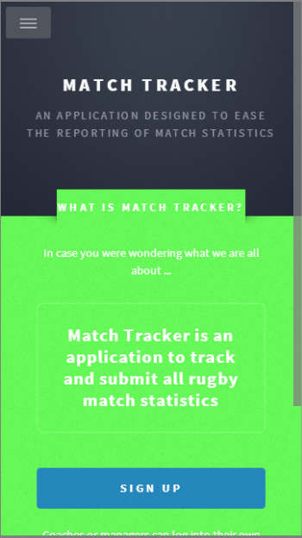

Sign Up Screen
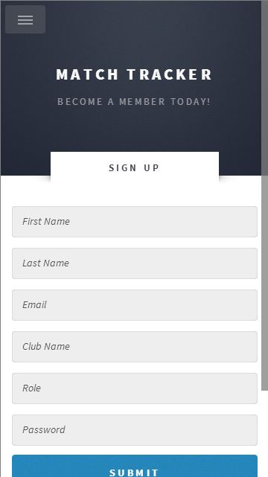

Create Fixture Screen
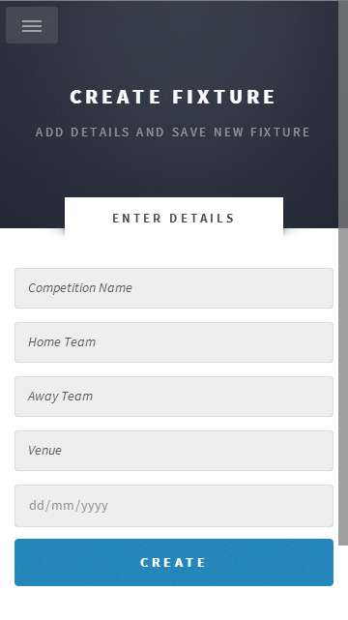

Mobile Application Navigation Menu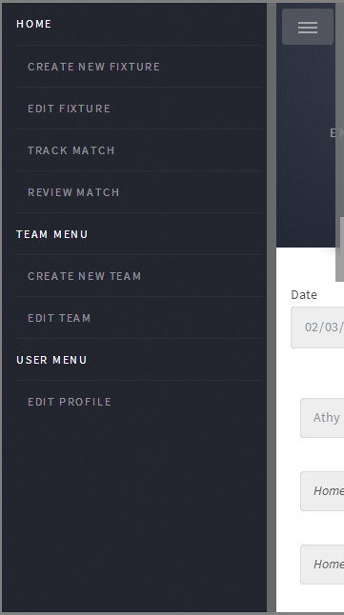

Edit Fixture Screens
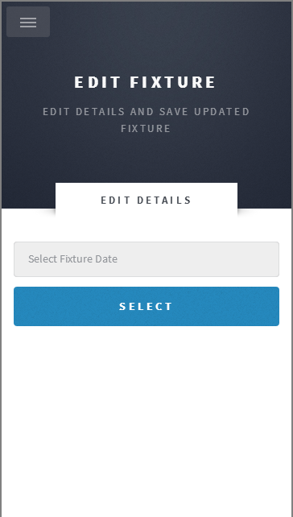
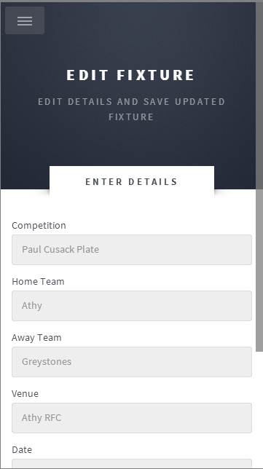

Track Match Screens
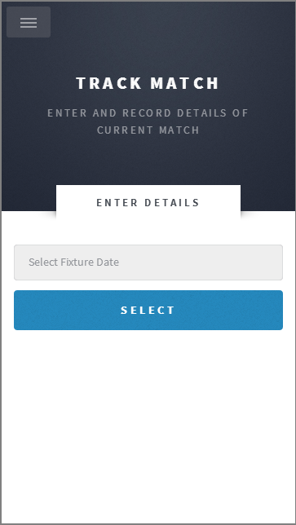
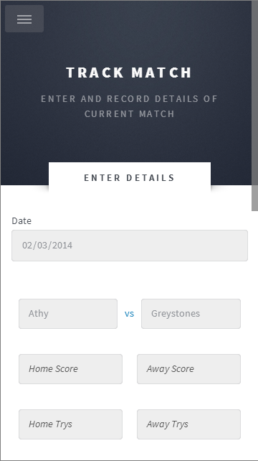

  - Website

Game Menu
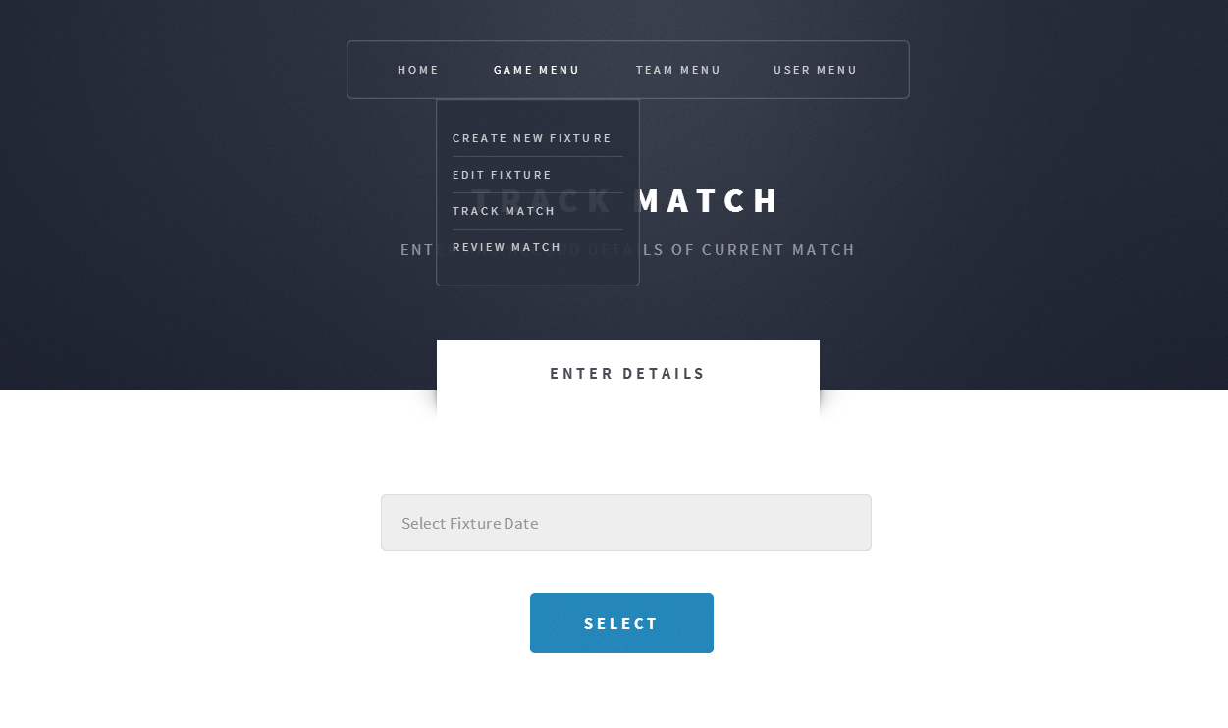

Team Menu
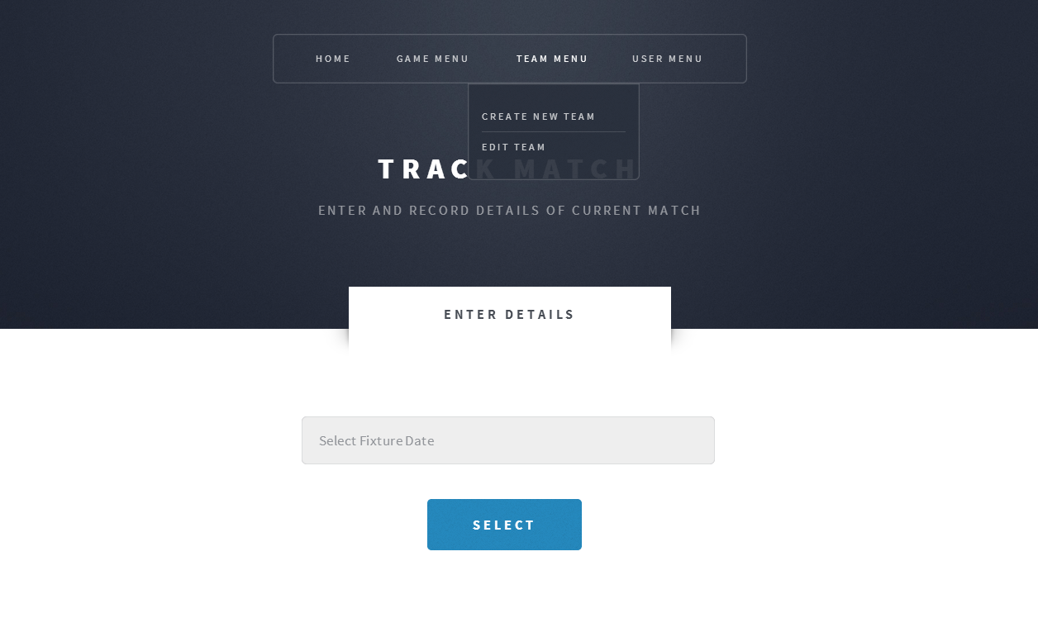

User Menu
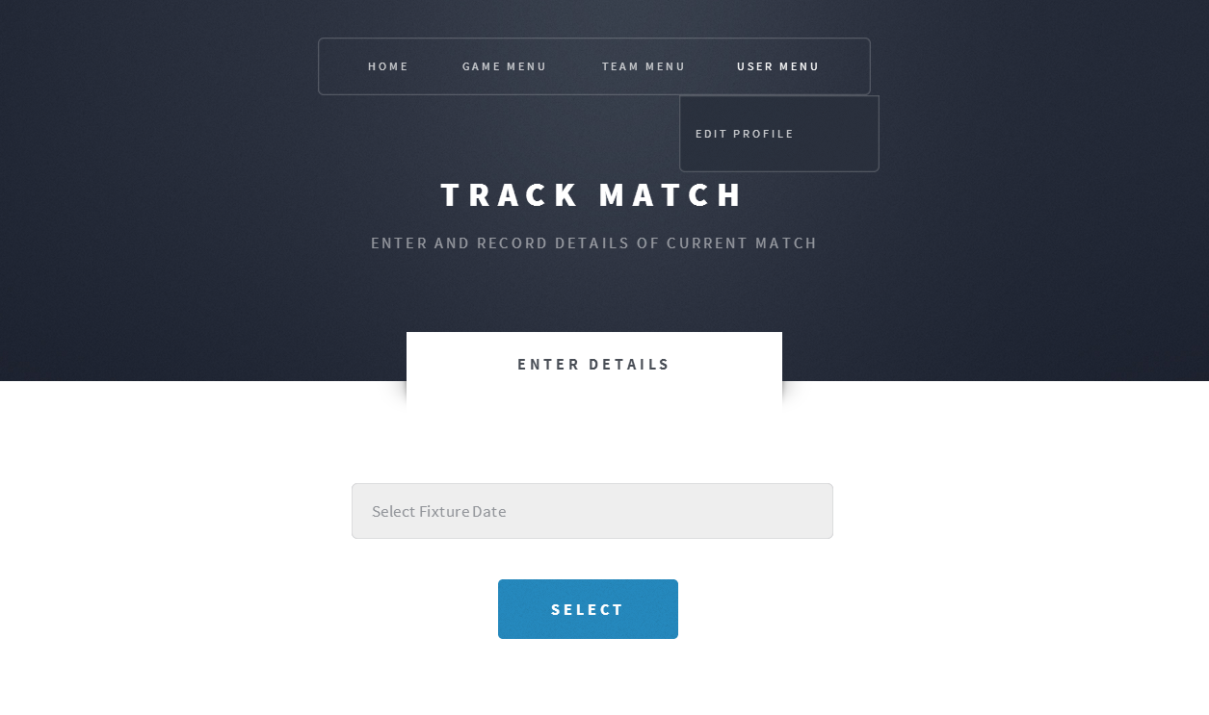

Select Fixture by Date
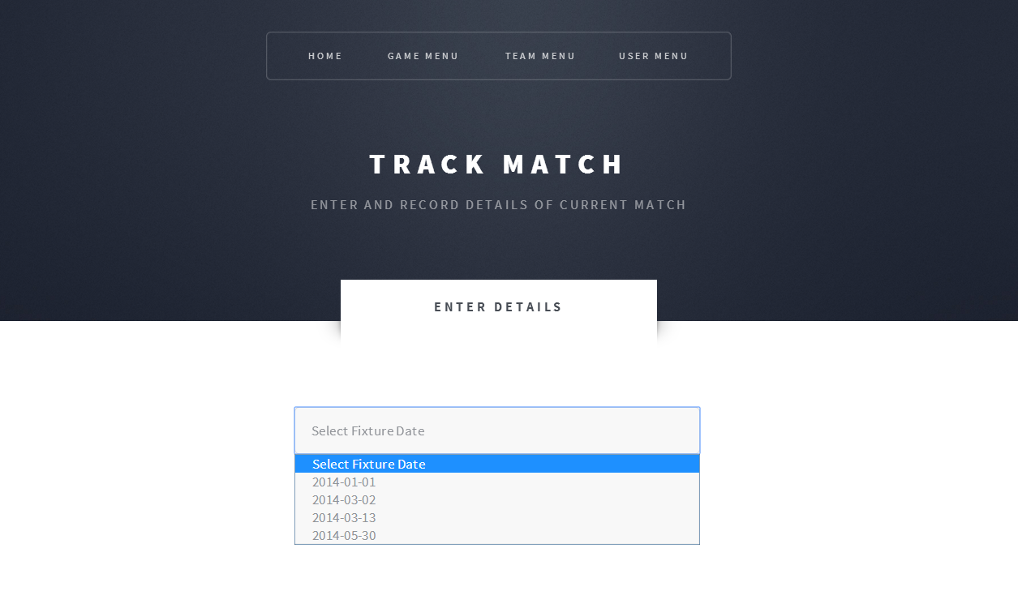

Fixture Selected
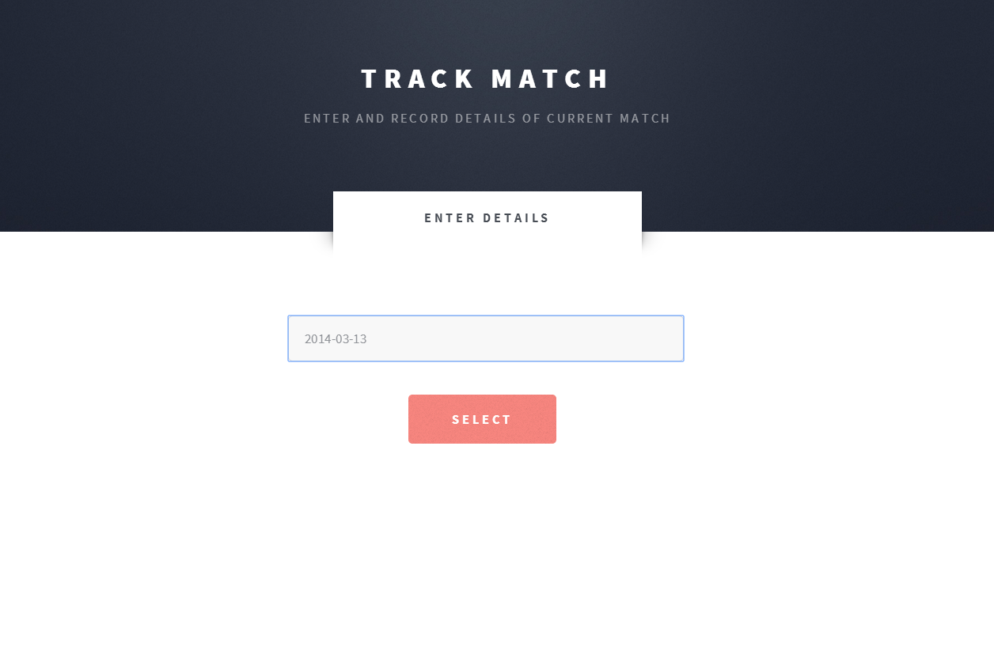

Track Match Screens
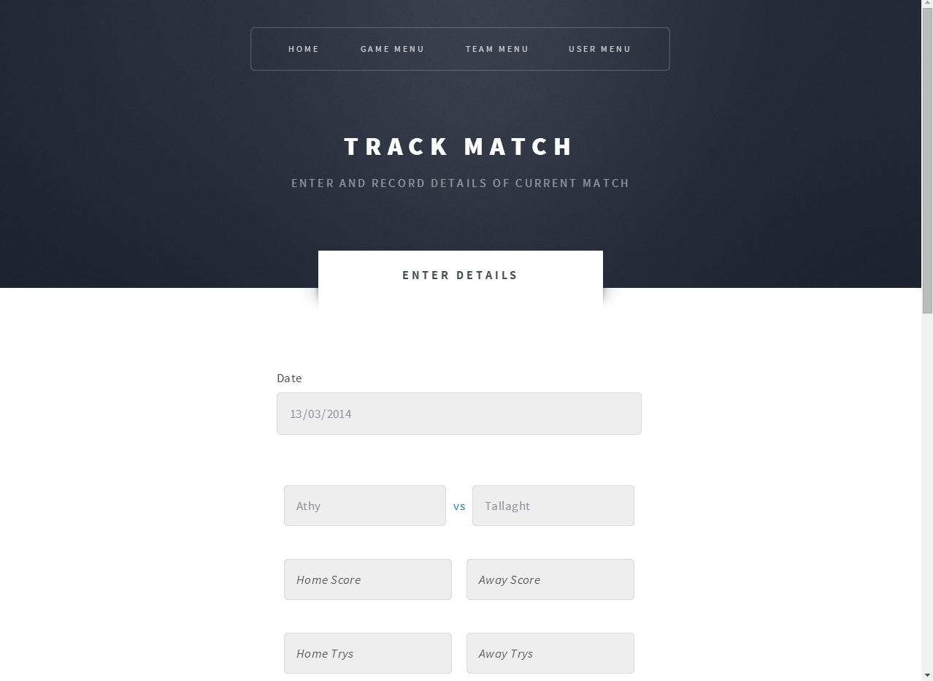
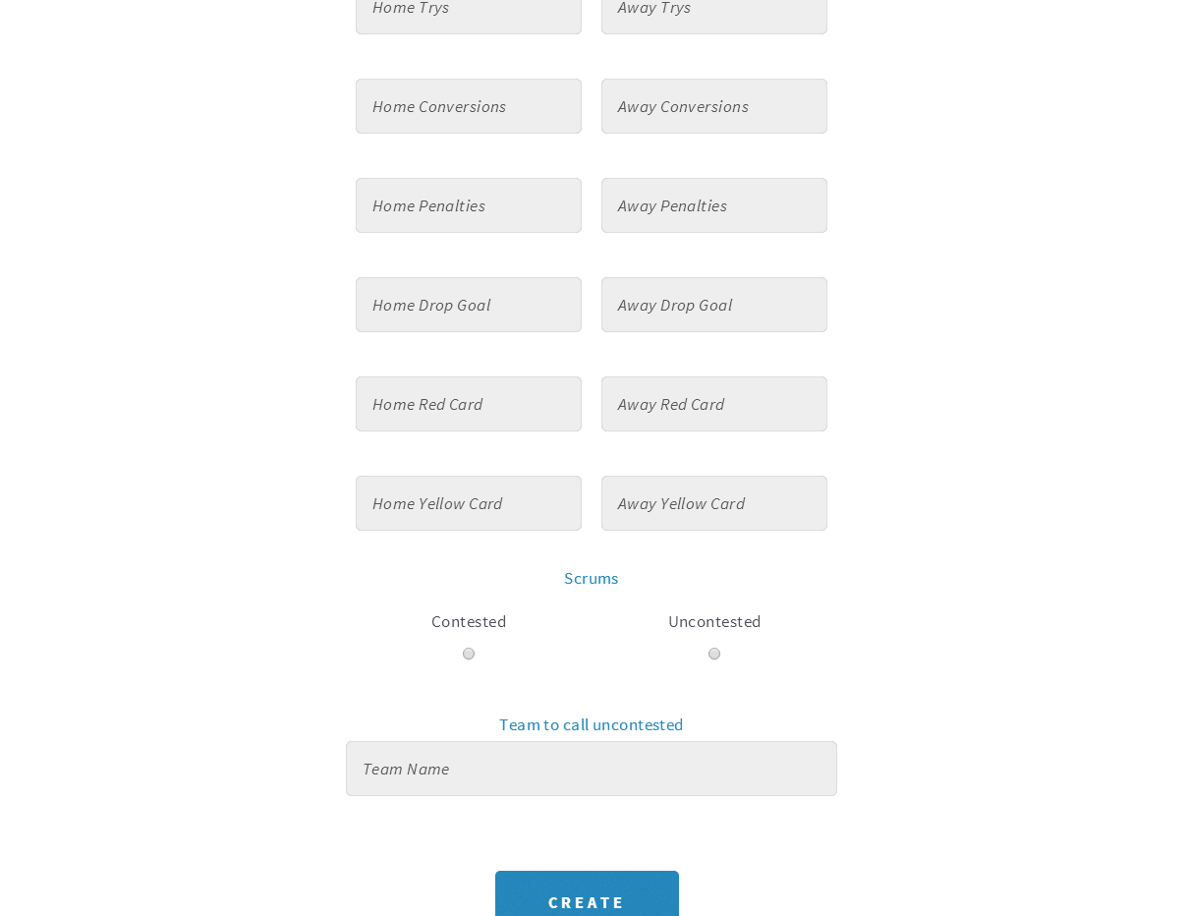

Adobe, PhoneGap. (2014). About the Project. Available: http://phonegap.com/about/ [accessed 11 January, 2014]
Google. (2014). What is Google App Engine?. Available: https://developers.google.com/appengine/docs/whatisgoogleappengine/ [accessed 11 January, 2014]
Apache Friends. (2014). XAMPP. Available: https://www.apachefriends.org/index.html [accessed 11 January, 2014]
JetBrains. (2014). IntelliJIDEA. Available: http://www.jetbrains.com/idea/ [accessed 11 January, 2014]

