Institute Of technology carlow
Final Project Report
Match Tracker Mobile Application
Laura O’Callaghan Conlon
4/28/2014

This document is a summary report of the work that has been completed and is currently outstanding for the Match Tracker Application. The document will also contain information on problems encountered during the course of this project and the actions taken to counteract same. All changes and deviations from the original project plan are also contained within.

Table of Contents
1. Introduction 3
1.1. Purpose and Content 3
1.2. Project Brief 3
2. Submitted Project Description 3
2.1. Match Tracker Application 3
2.2. Front End 4
2.2.1. Sign Up – Desktop Version 4
2.2.2. Sign Up – Mobile Version 5
2.2.3. Create Fixture – Desktop Version 6
2.2.4. Create Fixture – Mobile Version 7
2.2.5. Create Player – Desktop Version 8
2.2.6. Create Player – Mobile Version 9
2.2.7. Create Team – Desktop Version 10
2.2.8. Create Team – Mobile Version 11
2.2.9. Track Match – Desktop Version 12
2.2.10. Track Match – Mobile Version 13
2.3. Back End 15
3. Conformance to Specification and Design 15
3.1. Conformance to Specification 15
4. Learning Outcomes 15
4.1. Technical Learning 15
4.2. Personal Learning 16
5. Review of Project 17
5.1. Positives – What went right? 17
5.2. Negatives – What went wrong? 17
5.3. Work outstanding 17
5.4. Regrets 19
5.5. Future advice 19
5.6. Poor choices? 19
5.7. Implications of choices 19
6. Acknowledgements 20
6.1. Code sources 20
6.2. Those who helped 20
Bibliography 21

- Introduction
  - Purpose and Content
The purpose of this document is to outline any and all work that has been completed to date on the Match Tracker Application. The document will also cover in detail any work that is outstanding on the project in order to complete it to the final production version standard.
Also contained within this document are descriptions of all problems that were encountered while creating the Match Tracker Application and all solutions found to same. All variations from the original project plan are also included and any new features that were not previously documented or accounted for have been discussed here.
  - Project Brief
Match Tracker Application is a web application that uses a MySQL database for storing all app data. The application will allow users to create and edit players, fixtures and teams on the go as well as the ability to track and review matches that have been played by recording a set selection of match details on the side of the pitch. This allows for real time updating and access to the most recent match results for all teams using the application.
- Submitted Project Description
  - Match Tracker Application
The Match Tracker Application is a web application that is optimised for mobile browsing. The purpose of the application is to record and submit all team and match details for rugby matches within the Leinster Branch set up that is currently in place. The application can be easily altered to work within other organisations but currently focuses mainly on the requirements of the Leinster Branch.
At present the process within Leinster Branch on a match day is that the final scores, as well as a breakdown of the tries scored, conversions scored, penalties scored and drop kicks scored must be recorded on a paper team sheet. Along with the scores it must also be recorded if there were any yellow or red cards issued and against who. Also on the team sheet it must state if scrums were contested or uncontested and if uncontested, which team requested this. There must also be a record made of each player, what position they played and their personal player pin number. This sheet must then be signed by the referee and posted to Leinster Branch head office. Following this a text message must be sent to a fixtures secretary in the Branch again stating the final scores, a breakdown of the scores and yellow or red cards issues as well as contested or uncontested scrums. The fixtures secretary then manually inputs this information into a third party website which generates a results table and if there has been a yellow or red card issued she must also input this information into a player database so it will appear on the player’s record. The aim of the Match Tracker Application is do away with this process entirely.
  - Front End
The submitted application currently allows the user to sign up to the web or mobile site where they register their name, email, club and role within the club this will then be used, in a later version, to control access that users have by limiting them to only being able to access their own clubs and players.

Sign Up – Desktop Version
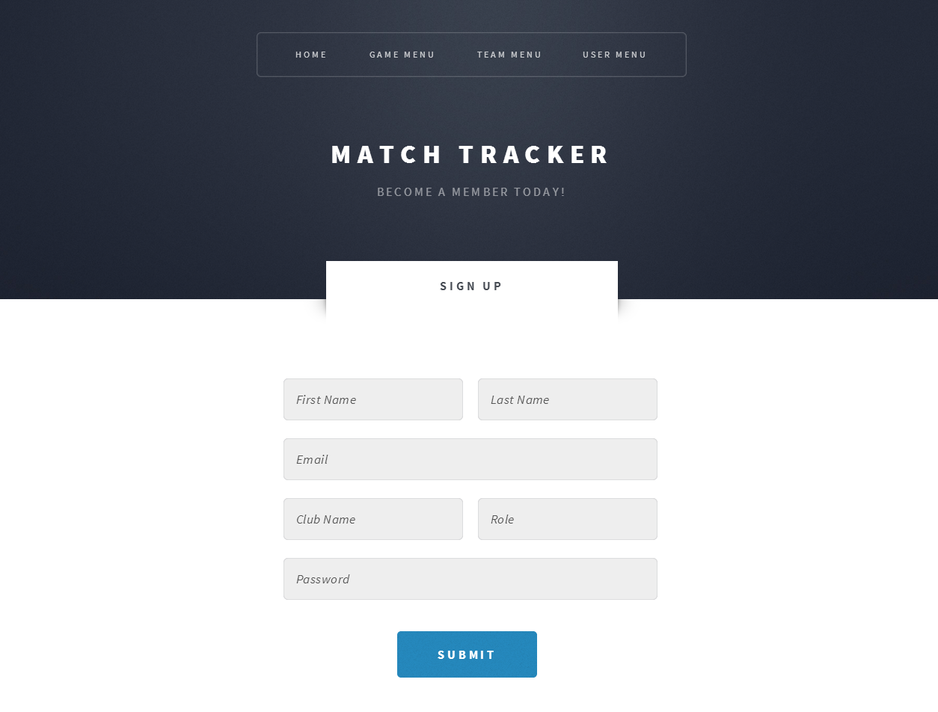

Sign Up – Mobile Version
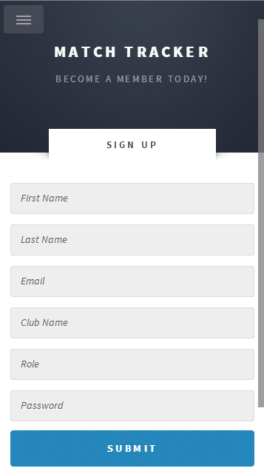

The Match Tracker Application then allows the user to create fixtures on the systems so that the details of all their upcoming matches are readily accessible on match days.

Create Fixture – Desktop Version
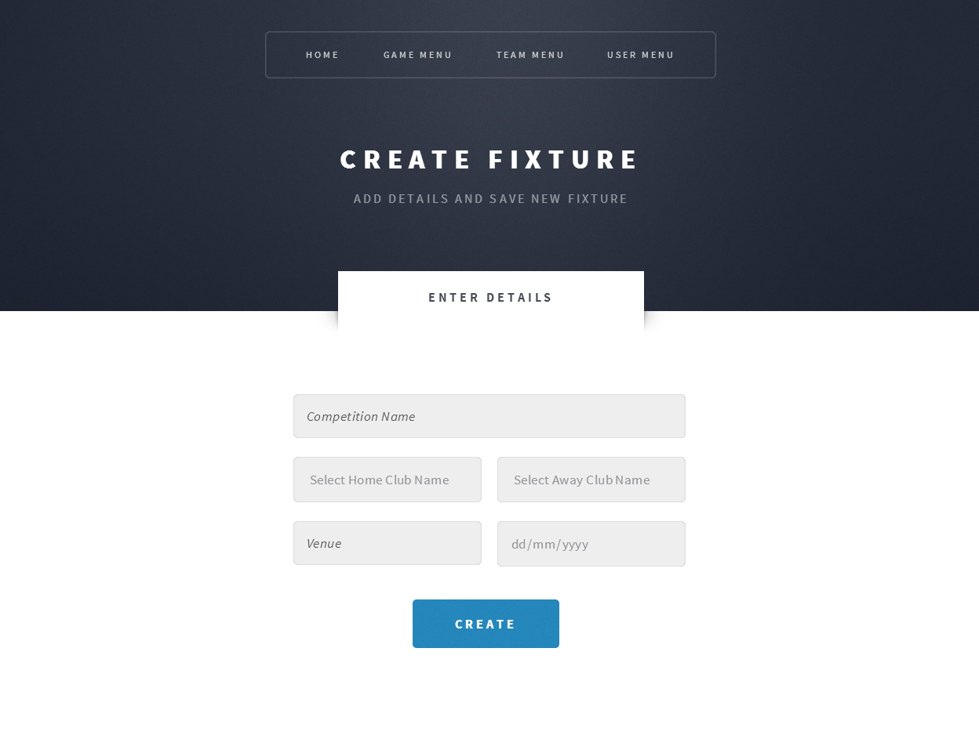

Create Fixture – Mobile Version
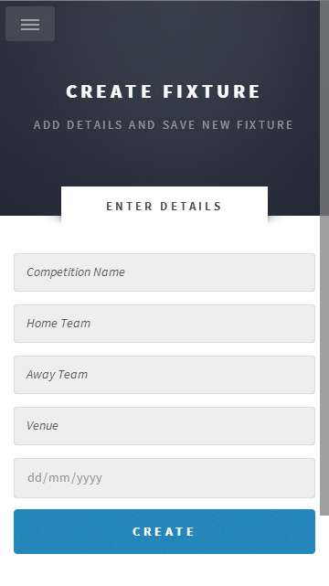

The Match Tacker Application allows user to create players by entering details such as player name, personal pin number and their primary club. Adding the players club is a element of data that will prove essential in the final version of the application.

Create Player – Desktop Version
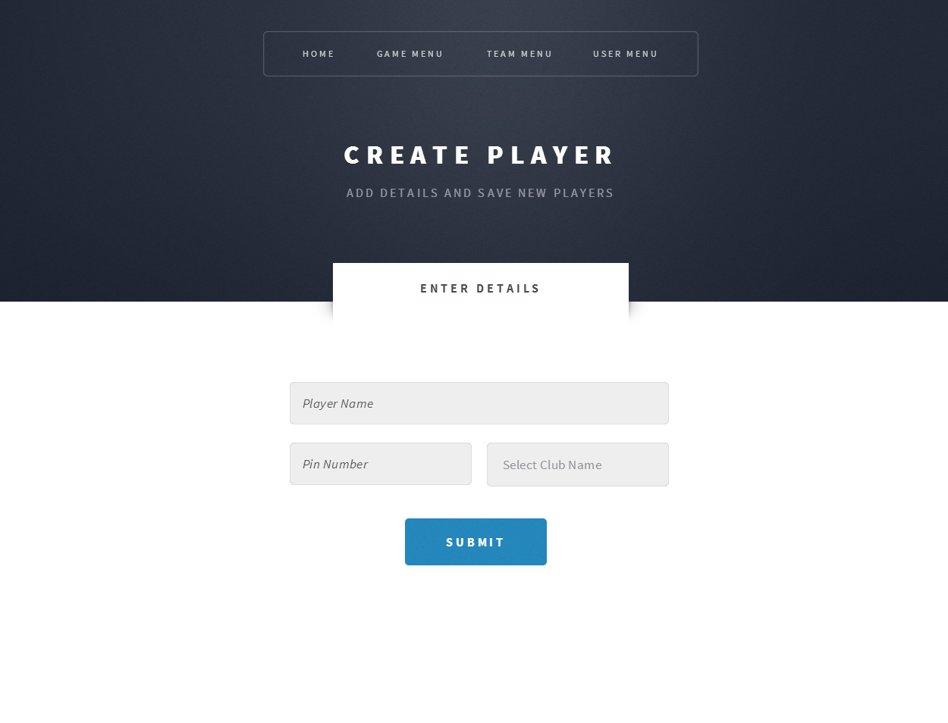

Create Player – Mobile Version
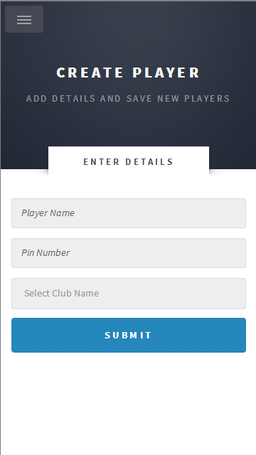

The Match Tracker Application also then allows the user to create teams for each fixture that is to be played. This is done by selecting the details of the fixture by selecting the fixture date and then the user may select their team of players by selecting all registered players from drop down lists for each position.

Create Team – Desktop Version
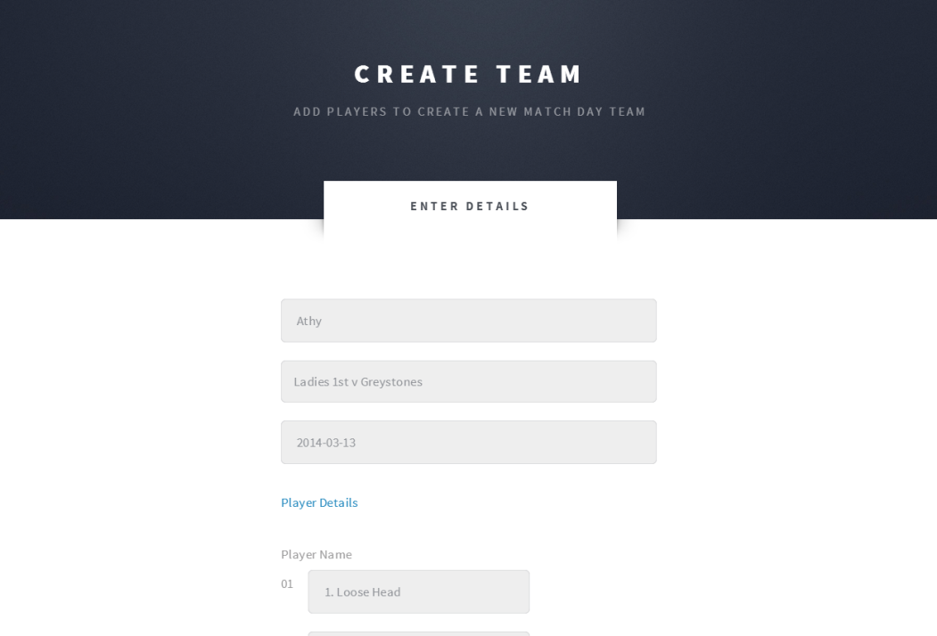
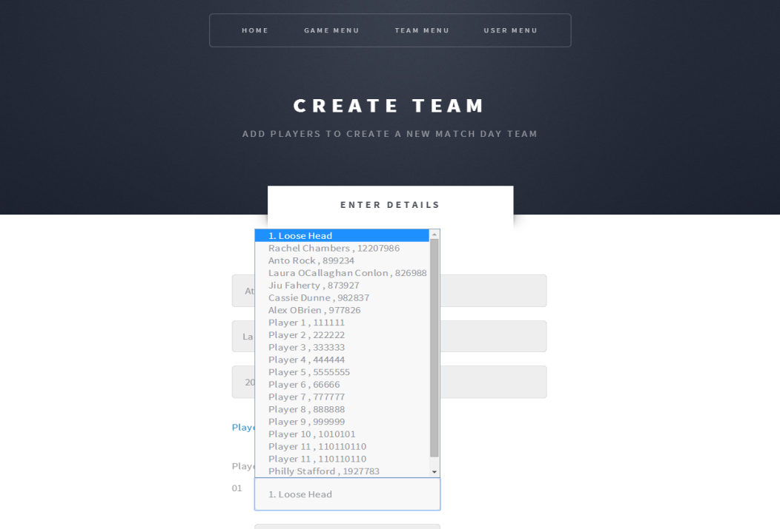

Create Team – Mobile Version
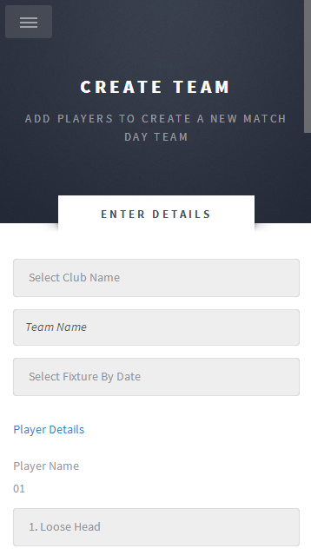

The main feature of the application is the ability to track the match statistics of a match that has been played. This requires users to fill out a form containing all the information about that match that is relevant to the Leinster Branch’s results department.

Track Match – Desktop Version
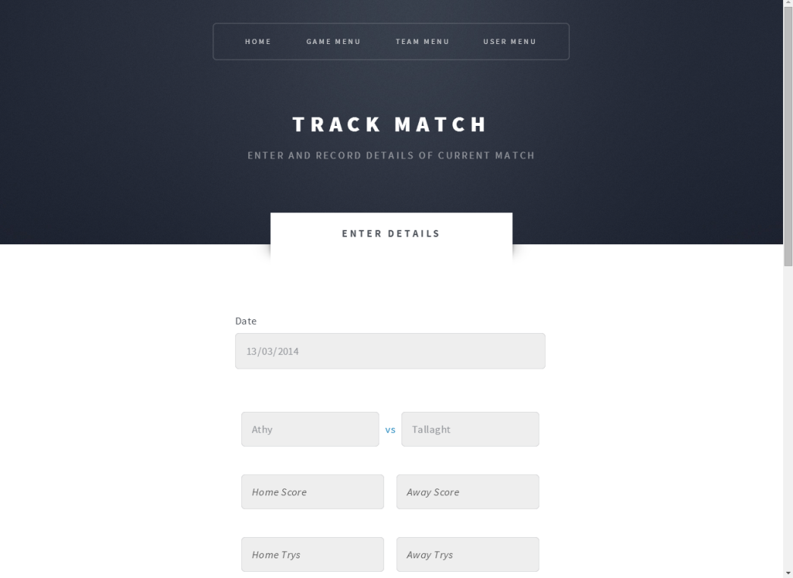
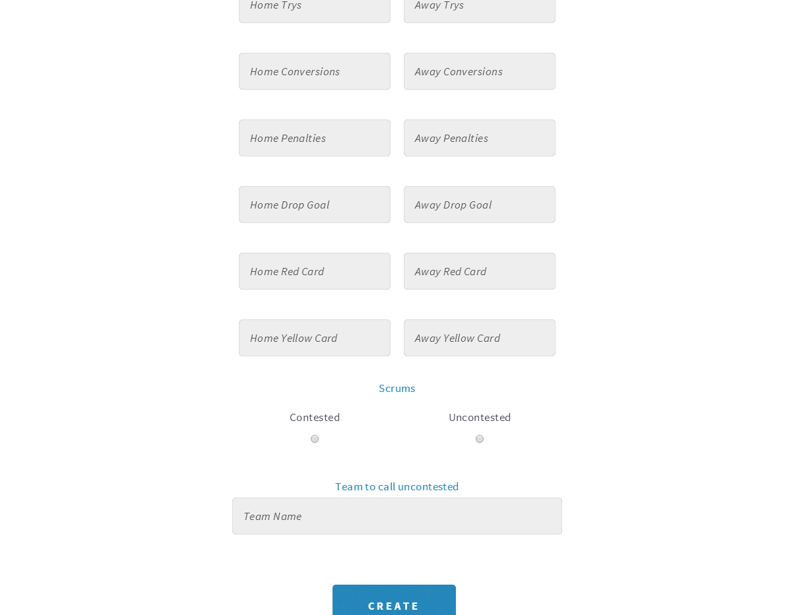

Track Match – Mobile Version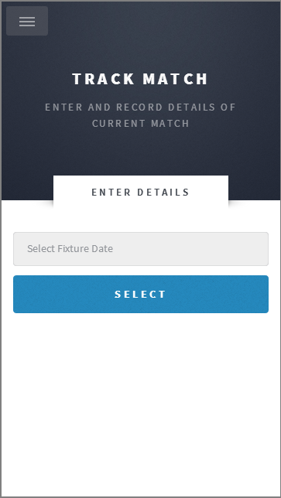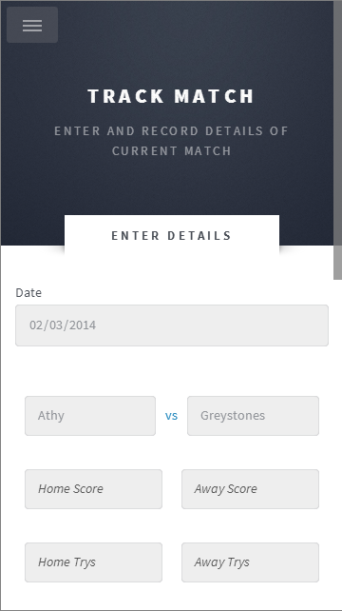

  - Back End
Currently the backend of this project is in the form of a MySQL database. There are separate tables for fixtures, players, teams, users and clubs. This is something that will change in future versions due to the fact that there is currently a database of all registered players and clubs in Ireland which is something that is being looked at integrating into this project in future versions.
- Conformance to Specification and Design
  - Conformance to Specification
Originally the projected specification of the application was to build a mobile application and a separate website that would have additional features for registered users to access. The initial plan was to make a hybrid application using PhoneGap which would work on both Android and iPhone devices natively as there is a 50/50 split in the devices being used by the surveyed target users. However due to time and equipment constraints this was not possible as a version one option. The project was then switched to an Android application but after further research this was deemed not to be the best option as it would rule out half of the target users straight away. Finally a web application that was optimised for mobile use was decided upon as the best option as this would allow users a unified experience regardless of device.
The submitted application is a web application that is written in HTML, Javascript and PHP, using CSS for styling and design. This way the users who access the system on a laptop or PC have the same user experience as those users who access the system on a mobile device or tablet.
Initially it was thought the there would be reduced options available on the mobile application than there was on the desktop site but due to the fact that design has changed from a native application to a web application this did not have to be the case any longer as the desktop website and the mobile website are one in the same and therefore allow for all options to be available at all times to the users regardless of device.
The GUI has changed drastically from the original specification, a lot of CSS has been added and a basic responsive template was used as a foundation for the design which is neat and minimalist.
- Learning Outcomes
  - Technical Learning
During the course of this project a greater understanding and knowledge was gained of the various types of application development. By initially investigating the hybrid application option, PhoneGap was discovered and quite a lot of research was put into learning how to develop hybrid applications, given more time this would have been an excellent solution for the project.
Following PhoneGap, Android development was investigated and a great deal was learned about same. Having previously touched on the subject during the course of these studies the opportunity to develop coding abilities in this area was greatly appreciated and a far deeper knowledge of android development was gained.
During the course of the actual development of this project a proficiency in PHP was gained that was entirely self-taught as no previous experience in this language was held. Having previously used HTML and CSS in smaller projects, this development gave the opportunity to develop these skills further.
A lot of learning had to be achieved on the structures of databases and the use of MySQL. Writing PHP code to manipulate data and integrating this into HTML and with the use of Javascript was something that proved a steep learning curve, especially having no working background in either.
  - Personal Learning
It was discovered through the course of this project that I am capable of learning and adapting to new programming languages such as PHP and Javascript both of which I had no previous experience in or tutoring. It was also discovered that although being an adequate programmer in such languages my personal preference lies with front end, web development, using HTML and CSS, it appears that this is the area I enjoying working in most. Aside from programming in the pure sense I greatly enjoyed the planning and requirement gather stages of this project. Working with potential end users to discover what exactly it was they required in such a system and figuring out the best possible way to implement these requirements.
Working under pressure is something that proves a positive thing for me. Due to the fact that the languages and technologies that were to be used in this project changed drastically more than once it cut down on the development time that was available in the end, this led to a very tight time line for the course of the project but it was an enjoyable yet pressurised experience.
The most positive achievements from this project are most definitely learning and becoming proficient in PHP and understanding the inner workings of MySQL databases.
- Review of Project
  - Positives – What went right?
The design of the project, the styling that was used was definitely a positive as it gave the website a clean, sleek look which is easy to navigate and cuts down on the time spend trying to figure everything out.
The ability to create and retrieve players, teams and fixtures very easily is definitely a major positive and something that will reduce the workload associated with the current system greatly.
The option to go with a web based application rather than a native application appears to have been a good choice a lot of potential users do most of their team admin work on a desktop or laptop and enjoy the ability to be able to use a mobile service that looks and behaves the same as the website. Although the downside of a web based application is that a data connection is required to use the app this is not a huge concern as all potential users that were surveyed have constant internet access on their mobile devices.
Following recent meetings with Leinster Branch representatives very positive feedback has been received from same, the Branch is excited about the potential in this project and has submitted a list of additional features that they wish to see included in the project. Leinster Branch has also suggested rolling out this application on a trial basis within the Youths section in order to get real-time feedback.
  - Negatives – What went wrong?
Due to the time constraints that were placed on the project from the switches in the technologies used, the progress of development was somewhat delayed. The projection was that version 3 of the outlined project would have been reached by the completion date, however to date, the project is only at the stage of mid-way through version 2 development. This is a massively negative issue that, unfortunately, has not been able to be rectified. Although there is a clear path to follow it is not ideal that progress is not very far down this path although now that the technology has been decided on and work has been progressing very quickly it is projected that version 2 should be completed in the very near future and version 3 is not too far behind that.

  - Work outstanding
The work that is outstanding to complete the initially projected version 3 content in this application is as follows;
- Login features for registered users – currently users can register and have their user data stored in a database but the entire site is open to everyone, this is something that will not be the case in further versions. It is projected that users will have to log in to their accounts in order to use and of the CRUD features. Non registered users may review upcoming fixtures and the results of played matches in the form of league tables.
- Displaying match results in a league table
- Linking all database tables in order to have all required information at all times in all screens needed
- Check if user is logged in not – if the user is logged in then the option to log out or edit the user profile must be displayed. If the user is not logged in then the aforementioned options should not be displayed and only the option to log in should be displayed. The log in option should not be displayed if the user is actually logged in.
- Passwords for registered users must be encrypted
- When Tracking a Match, check if the scrums are contested or uncontested, if uncontested then require a uncontested requesting team name to be selected from a dropdown box containing only the two teams featuring in the fixture in question
- Flagging players when they have been entered into a team if they are ineligible for that given fixture i.e. Player needs regarding, player is a dual status player etc.
- Generate a list of players that are eligible for a knockout match – allow user to see a dropdown list of only eligible players when creating a team for a final or semi-final e.g. A player must have played at least 2 pool games with a team before they can feature in a semi-final or a final.
- Record whether a player has started or come on as a sub in a game – this is in line with the 48hr rule whereby a player can play two matches within 48hrs but cannot start in both matches.
- Sort youth players based on their date of birth so they are only available to be included in a team that coincides with their age group
- Make team statistics available from previous fixtures for all users on the system – this will allow coaches to analyse any upcoming fixtures and opponents based on their past performances
- Message board or forum for members to advertise or request friendly matches
- Ensure that teams may only be edited before the fixture has been played, team sheets may not be altered after the fixture has been played and tracked
Some of these outstanding features have come about only very recently as per the requests of the Women’s Development Officer for Leinster Branch. At the most recent meeting with same, she expressed her enthusiasm for this application and based on some research she has done personally, has added in some additional features that she would like to see incorporated into the project. When these remaining features have been added she stated that Leinster Branch would like to role out this project within the current Youth set up as a real time trial.
  - Regrets
The major regret for this project is not landing on the decision to develop a web app from the beginning. A lot of time was wasted and this is something that is regretful as the progress of the applications development was hindered by this.
The other possible regret is using MySQL rather than MongoDB, this is a possible regret as further research into Mongo must be done to decide completely but it is a possibility for future versions of this application.
  - Future advice
Advice for anyone doing this or a similar project would be to decided definitively on the technology to use as soon as possible as a lot of development could have been done in the time that was wasted on trying different technologies rather than deciding on the web app from the beginning and just developing for that.
The use of Git was a massive help in this project as it allowed an efficient version control system to be used throughout the course of the project. This was useful in many ways, from backing up each working version of the application to allowing various options to be explored and compared throughout the development process.
Another tool that should be used by anyone seeking to undertake a similar project is Trello, this is a project tracking application that allows the user to create cards for each of the numerous parts of the development or project documentation that has to be completed and then as the work is in progress the cards can be moved to a “Doing” column and then on to a “Done” column. This is incredibly useful with regard to time management and gauging that progress that is being made on a project. Trello also allows the creation of check lists within each card so for example in this project the card for this final report has a check list featuring each section heading that was required in the document. This again, allowed for progress to be tracked during the course of the project.
  - Poor choices?
A possible poor choice in this project may have been to use MySQL database. During the course of the project MongoDB presented itself as an option, possibly a better option for this application but MySQL is working sufficiently even if it could possibly be better.
  - Implications of choices
One of the biggest implications of a choice made in this project was the lack of time due to choosing to try and write a hybrid app and then an Android application along with a complementary website. The implication of this choice was massive with regard to time to develop, although the plan is firmly in place the progress of development is not as far on as would be ideal.
- Acknowledgements
  - Code sources
In developing this application a basic responsive web template was used initially to form the foundation of the website. This template was altered in both functionality and design to lead to the submitted project. Credit for this template must go to n33 of HTML5 UP
  - Those who helped
Thanks must be given to Chris Meudec for all the help and support offered throughout the year as Project Supervisor. Huge credit is to be given for being always available in person and via email for any and all questions and queries however big or small.
Thanks also to all Leinster branch representatives who have given valuable input along to the way

Bibliography

HTML5 UP (2014). Escape Velocity. Available: http://html5up.net/ [accessed 12 November, 2013]

