CAIRDE

**Car Sharing App**

User Manual



18th April 2018

BSc (Hons) Software Development

**Name:** Dylan Lawlor

**Year:** 4th year

**Student ID:** C00197013

**Supervisor:** Lei Shi

# Abstract

The purpose of this document is to provide instruction regarding the installation and use of this app.

Contents

Abstract 1

System Requirements 3

Minimum System Requirements 3

Recommended System Requirements 3

Additional Requirements 3

Installation Instructions 4

User Guide 5

Login 5

Register 6

Set Up Profile 7

Main Menu 8

Create a Journey 9

Searching for a Journey 10

Accepting An Applicant 11

# System Requirements

## Minimum System Requirements

* Android Smartphone with version 4.4 (KitKat) or greater installed
* Internet Access is required at all times
* 32MB free storage space on device

## Recommended System Requirements

* Android Smartphone with version 7.1 (Nougat) or greater installed
* Internet Access is required at all times
* 32MB free storage space on device

## Additional Requirements

The application also requires access to the devices location data for the map functionality, and access to modify the phones storage to save user preferences. No other permissions are required.

# Installation Instructions

The apk may be downloaded from the project website at:

<http://glasnost.itcarlow.ie/~softeng4/C00197013/index.html>

Or

<https://drive.google.com/open?id=1NxhdGq1dV5WC9BsswfCLjQSO2NDEmaVh>

* Download apk from one of the links above
* On your device go to Settings
* Scroll down to security and select Unknown sources
* Now find the downloaded apk in your file explorer
* Click the apk file and confirm installation
* App will install automatically and can be run once this process completes

# User Guide

This section will provide a brief guide into how to use the application.

## Login

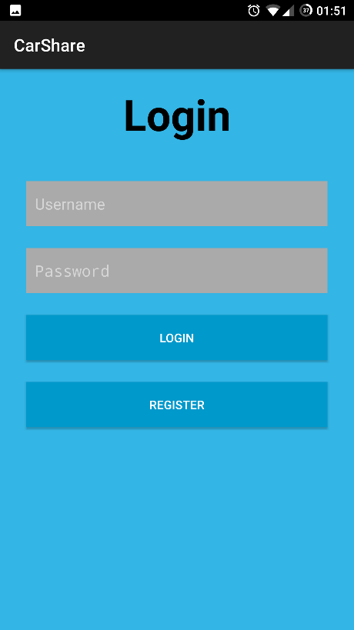

If a user account has already been set up, enter your username and password then click login. Otherwise click Register.

## Register

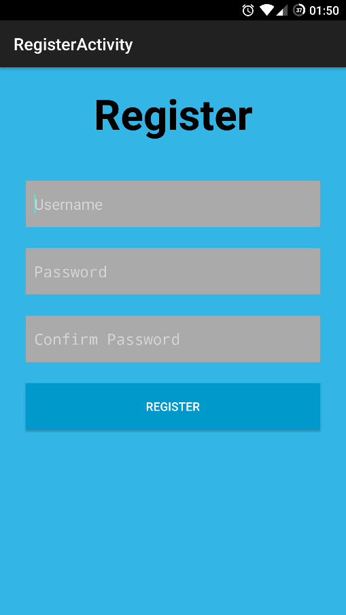

To register with the app simply choose a username and password and click register. The username must be unique (The app will inform you if it is already taken) so I suggest using something like an email address. The username is private and only used for login.

## Set Up Profile

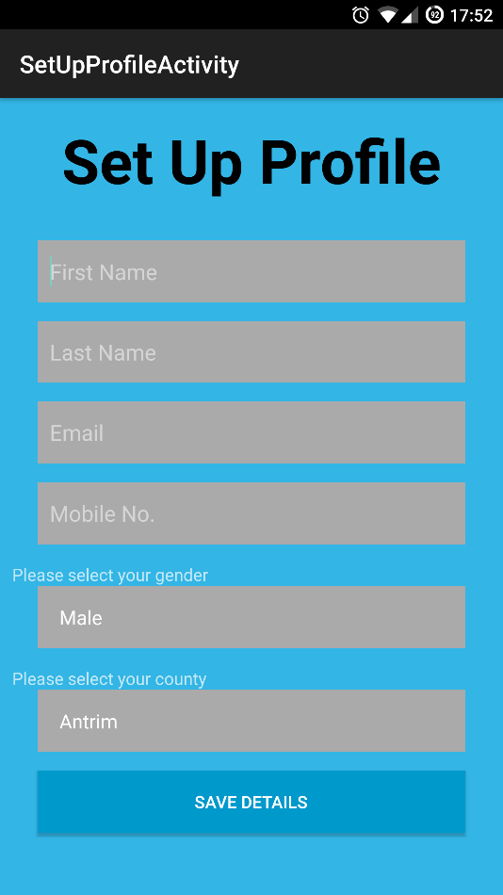

This screen will be displayed the first time you log into the app. Simply fill in your details and hit Save Details. Your information is private and not shared with any third-parties. Your name will be displayed to other users when you join a Journey. Your email address is used to send you notifications.

## Main Menu

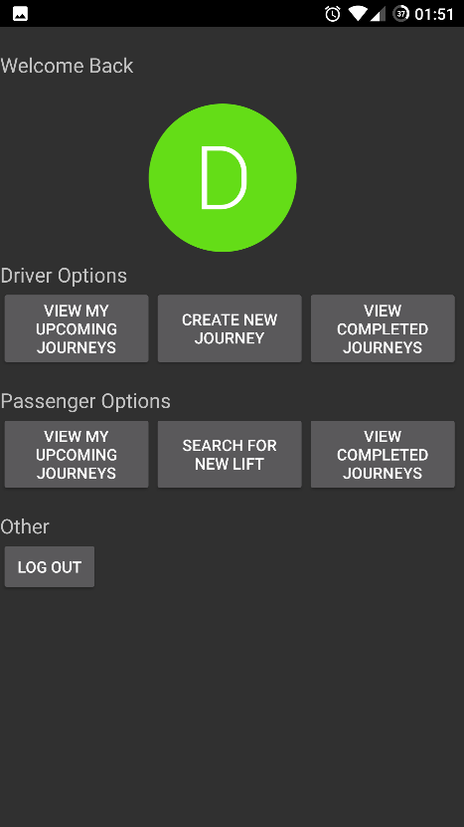

From this screen simply tap the activity you wish to start.

## Create a Journey

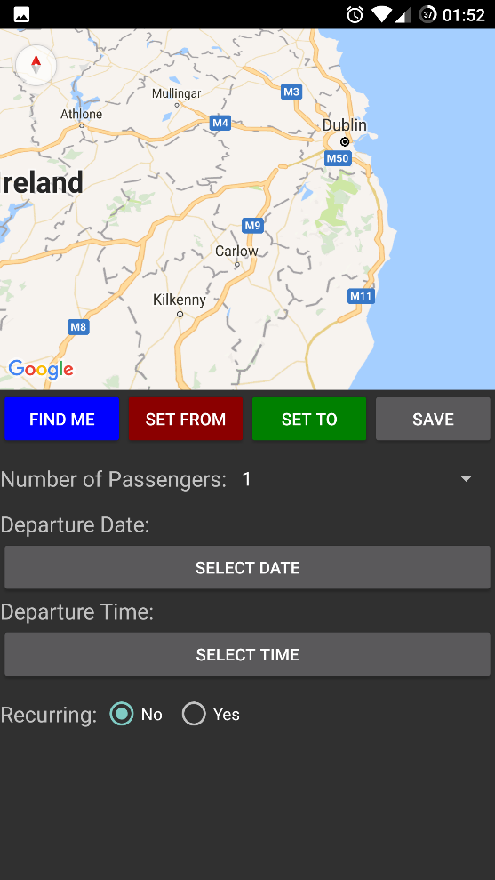

To create a journey first navigate the map to your starting location and click Set From. This will drop a red marker on the map. Adjust this marker if need be by re-navigating the map and clicking Set From again. Do the same for your destination except this time click Set To.

Once you are happy with the route use the drop down to select the number of seats you have available on this Journey. Then click select date and select the departure date from the calendar. Do the same for departure time. If you wish to create multiple copies of this Journey on different days, simply toggle recurring to yes, and use the add dates button to add as many additional dates as you require. Once satisfied hit the save button on the right under the map to save the Journey.

## Searching for a Journey

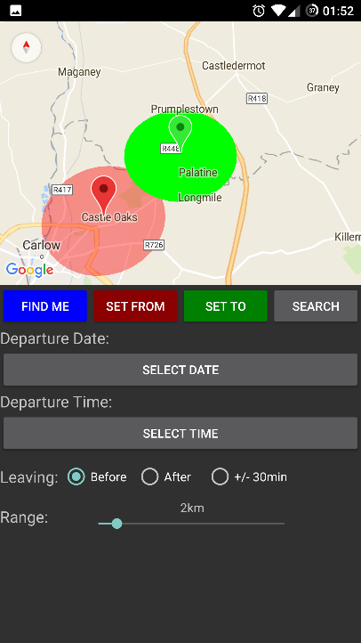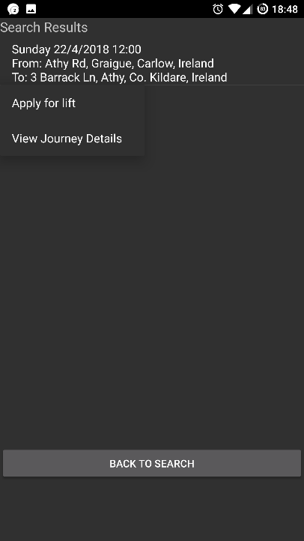

To search for a journey first navigate the map to your starting location and click Set From. This will drop a red marker on the map. Adjust this marker if need be by re-navigating the map and clicking Set From again. Do the same for your destination except this time click Set To. Then click select date and select the departure date from the calendar. Do the same for departure time.

Now select the Leaving option that best suits you:

* Before – Any Journey departing up to 1 hour before the selected departure time
* After – Any Journey departing up to 1 hour after the selected departure time
* +/- 30min – Any Journey departing up to 30min before and 30 min after the selected departure time

Finally use the range slider to select the area around your location in which to search for lifts. Hit search to view the results.

On the results screen tap a journey and click Apply for lift to apply for a position on ths Journey.

## Accepting An Applicant

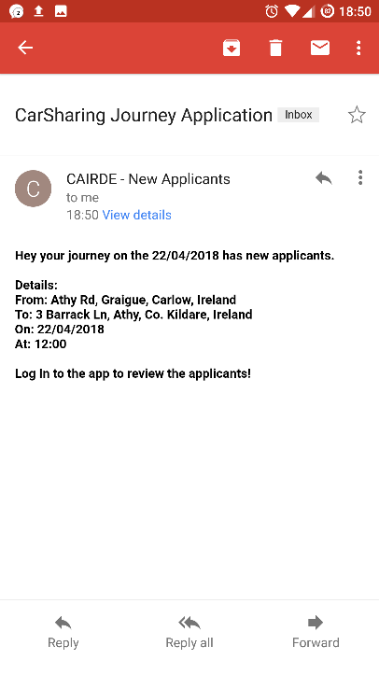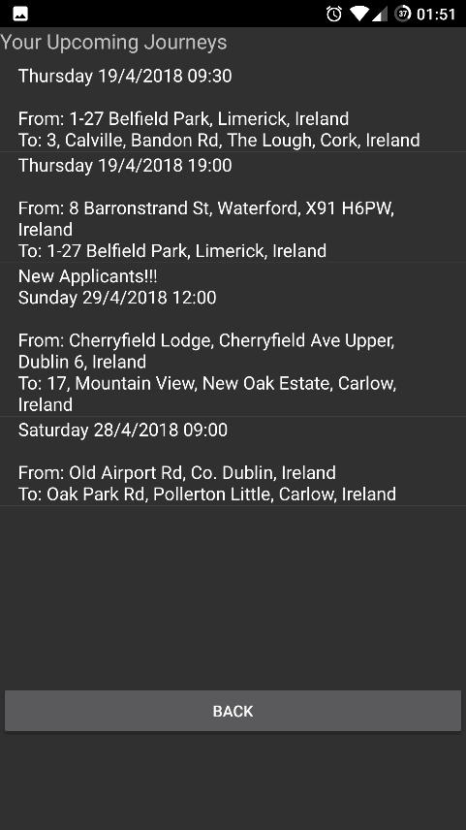

When you receive an email notification from the app stating that you have new applicants for one of your upcoming Journeys, simply Log into the app and click, View my Upcoming Journeys from the Driver options.

Find the Journey that has new applicants and tap it to select view details.

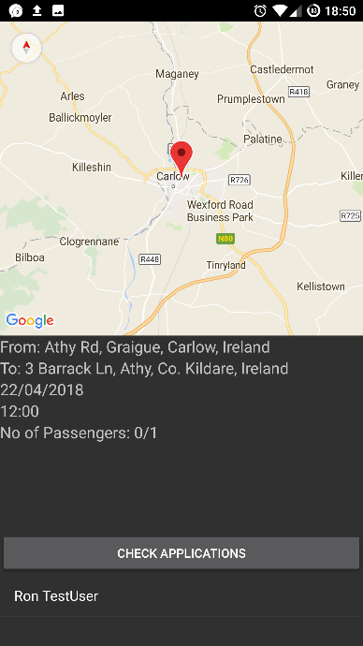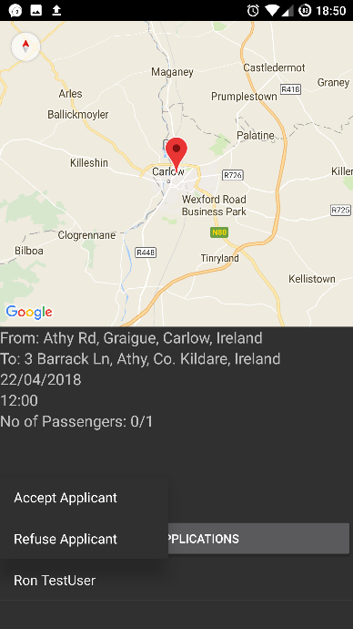

From this screen click check Applicants. Now you can choose to accept or refuse an applicant by tapping their name. Accepting an applicant will add them to the Journey and send them an email notification