Web-Based Music School Manager
Design Manual - Database

Author: Aaron Redmond
Student ID: C00002396
Supervisor: Paul Barry

Contents
Contents 2
1 Introduction 4
2 Tables 5
2.1 Users 5
2.2 Schoolinfo 6
2.3 Timetableinfo 6
2.4 Subjectstaught 7
2.5 Subjects 8
2.6 Studentgrades 9
2.7 Rooms 10
2.8 Personalisation 10
2.9 News 11
2.10 Lessons 12
2.11 Instruments 13
2.12 Grouptypes 13
2.13 Groups 14
2.14 Groupparticipants 15
2.15 Grades 16
3 Entity Relationship Diagram 17

Introduction
This document is intended to be an accompaniment to the design manual. It describes the database structure and it tables. The following is some information on the database:
- Database: MySQL
- Database Name: musicschool
- Tables: 15
The following section describes each table in detail, with the final section containing the entity relationship diagram.

Tables

Users
Figure 1: users table
This table stores all the basic user information.
Table name: users
Fields: 11
The users table contains the following fields:
Field Name | Description
user_id | The primary key for the table
username | The users login name
user_password | The users login password
user_forename | The user forename
user_surname | The users surname
user_email | The users e-mail address
user_address | The users home address
user_telephone | The users home telephone address
user_mobile | The user’s personal mobile phone number
user_type | Specifies the users login type, can contain one of three different values: admin, teacher or student
user_verified | This is a Boolean value, either 1 or 0, 1 indicating that the user is valid and can log in, 0 indicating that the user has registered an account but has not been verified

Schoolinfo
Figure 2: schoolinfo table
This table stores the basic school information.
Table name: schoolinfo
Fields: 5
The schoolinfo table contains the following fields:
Field Name | Description
school_id | The primary key for this table
school_name | The schools name
school_address | The schools address
school_phone | The schools phone number
school_email | The schools e-mail address

Timetableinfo
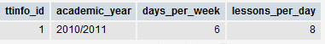
Figure 3: timetableinfo table
Table name: timetableinfo
Fields: 4
The timetableinfo table contains the following fields:
Field Name | Description
ttinfo_id | The primary key for this table
academic_year | The current academic year
days_per_week | The number of days the school operates per week
lessons_per_day | The number of lesson periods in a day

Subjectstaught
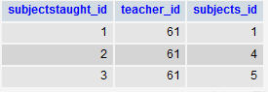
Figure 4: subjectstaught table
This table stores the subjects taught by each teacher. It’s a simple lookup table containing two foreign keys; one to the teacher stored in the users table and the second to the subject stored in the subjects table.
Table name: subjectstaught
Fields: 3
The subjectstaught table contains the following fields:
Field Name | Description
subjectstaught_id | This is the primary key for this table
teacher_id | This is a foreign key pointing to a teacher record in the users table
subjects_id | This is a foreign key pointing to a subject record in the subjects table

This table is linked to the following tables: users and subjects.

Subjects
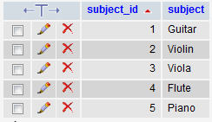
Figure 5: subjects table
This table stores all the subjects offered by the school.
Table name: subjects
Fields: 2
The subjects table contains the following fields:
Field Name | Description
subject_id | The primary key for this table
subject | A subject taught within the school

Studentgrades
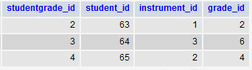
Figure 6: studentgrades table
This table stores the instruments and their associated grades for a student. It’s a simple lookup table containing three foreign keys.
Table name: studentgrades
Fields: 4
The studentgrades table contains the following fields:
Field Name | Description
studentgrade_id | This is the primary key for this table
student_id | This is a foreign key pointing to a student record in the users table
instrument_id | This is a foreign key pointing to a student record in the users table
grade_id | This is a foreign key pointing to a grade record in the grades table

This table is linked to the following tables: users, instruments and grades.

Rooms
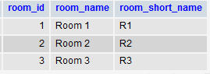
Figure 7: rooms table
Table name: rooms
Fields: 3
The rooms table contains the following fields:
Field Name | Description
room_id | The primary key for this table
room_name | This field stores the room name
room_short_name | This field stores the shortened room name

Personalisation
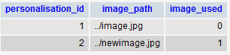
Figure 8: personalisation table
Table name: personalistaion
Fields: 3
The personalisation table contains the following fields:
Field Name | Description
personalisation_id | The primary key for this table
image_path | The path to an uploaded image
image_used | A Boolean which indicates if the file is to be used

News
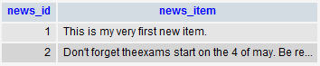
Figure 9: news table
Table name: news
Fields: 2
The news table contains the following fields:
Field Name | Description
news_id | The primary key for this table
news_item | This field contains the news items

Lessons
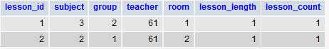
Figure 10: lessons table
This table stores all the created lessons. It contains four foreign keys.
Table name: lessons
Fields: 7
The lessons table contains the following fields:
Field Name | Description
lesson_id | The primary key for the lessons table
subject | This is a foreign key pointing to a subject record in the subjects table
group | This is a foreign key pointing to a group record in the groups table
teacher | This is a foreign key pointing to a teacher record in the users table
room | This is a foreign key pointing to a room record in the rooms table
lesson_length | This field contains the length of the lesson (in periods)
lesson_count | This field contains the number of times the lesson is repeated per week

This table is linked to the following tables: users, groups and subjects.

Instruments
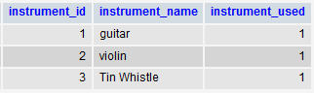
Figure 11: instruments table
Table name: instruments
Fields: 3
The instruments table contains the following fields:
Field Name | Description
instrument_id | The primary key for this table
instrument_name | The name of an instrument
instrument_used | Boolean value, indicating whether the instrument is currently used in the school (1=true/0=false)

Grouptypes
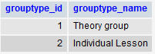
Figure 12: grouptypes table
Table name: grouptype
Fields: 2
The grouptype table contains the following fields:
Field Name | Description
grouptype_id | The primary key for this table
grouptype_name | The name of a group type

Groups
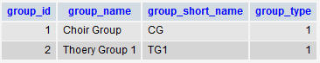
Figure 13: groups table
This table stores the information on groups, it contains one foreign key.
Table name: groups
Fields: 4
The groups table contains the following fields:
Field Name | Description
group_id | The primary key for the groups table
group_name | The name of the group
group_short_name | The short name for the group
group_type | This is a foreign key pointing to a group type record in the grouptype table

This table is linked to the following table: grouptype.

Groupparticipants
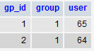
Figure 14: groupparticipants table
This table stores the students participating in a group. It’s a simple lookup table containing two foreign keys.
Table name: groupparticipants
Fields: 3
The groupparticipants table contains the following fields:
Field Name | Description
gp_id | The primary key for the groupparticipants table
group | This is a foreign key pointing to a group record in the groups table
users | This is a foreign key pointing to a student record in the users table

This table is linked to the following table: groups and users.

Grades
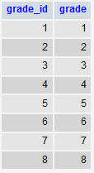
Figure 15: grades table
Table name: grades
Fields: 2
The grades table contains the following fields:
Field Name | Description
grade_id | The primary key for this table
grade | This field stores all the available grades

Entity Relationship Diagram
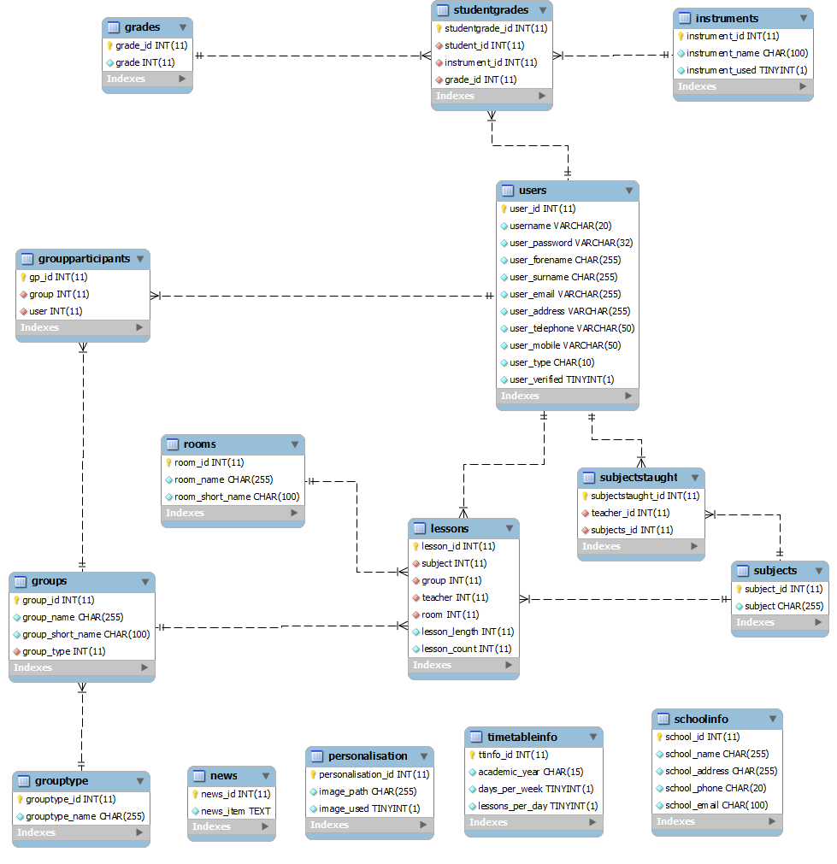
Figure 16: ER diagram for the musicschool database

