User Manual

Student Name: Wen Liu
ID Number: C00105088
Project: Fingerprint Recognition
Supervisor: Nigel Whyte (M.Sc. MIEEE)
Date: 10/04/2010

Contents

- Minimal System Requirements …………………………………………. 2

- Application Installation ………………………………………………… 3

- Function Instructions ……………………………………………………… 6
- Enroll a fingerprint ……………………… 6
- Match two enrolled fingerprints ……………………… 11
- Recognize an unenrolled fingerprint ……………………… 15
- Save matching/recognition result ……………………… 18
- Manage enrolled fingerprint records ……………………… 19
- Check project “About” information ……………………… 23
- Read application help document ……………………… 24

- Application Uninstallation ………………………………………………… 25

- Minimal System Requirements

Operating System: Microsoft Windows XP/ Vista serial

CPU: 780 MHz, Intel Pentium III

Memory: 512 MB

Disk space required: 14MB

Prerequisites: .Net Framework 3.5
Windows Installer 3.1
Adobe Reader 9

- Application Installation

Step 1:
Put application install CD into your CD or DVD ROM.
Double click “setup” exe file on the CD.
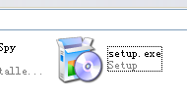

Step 2:
Installer prepares for installation and installation welcome dialog window will be shown.
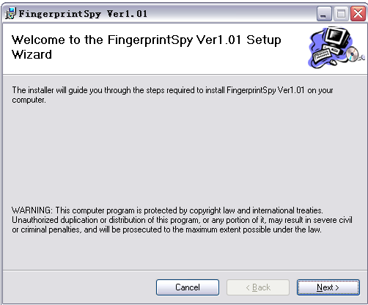
Click “Next” button to next step.

Step 3:
Click “Browse” to change install folder or using the default folder.
Click “Disk Cost” to check available disk space on each disk drive and required disk space of the installation.
Select user account availability of the FingerprintSpy Ver. 1.01 – every user accounts on the computer or current account only.
Click “Next” to next step.

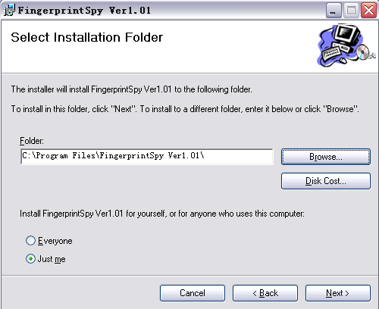

Step 4:
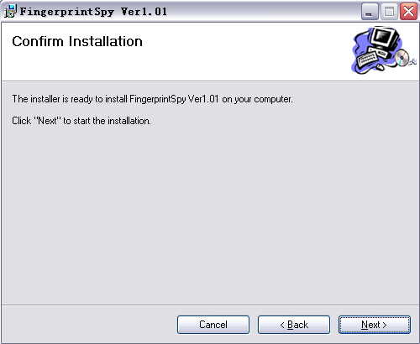
Click “Next” to confirm the installation.

Step 5:
During installation, installer will check the prerequisites (.Net Framework 2.0 and Windows Installer 3.1) are properly installed. If not, it will install them automatically. It will take a few minutes to install the application.
User can click “Cancel” to abort the installation.
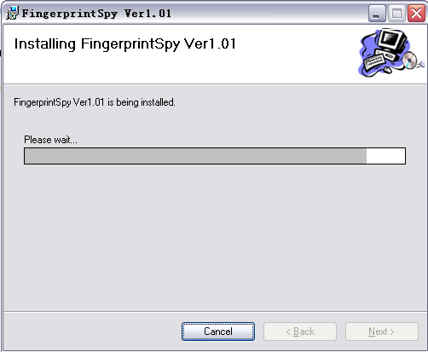
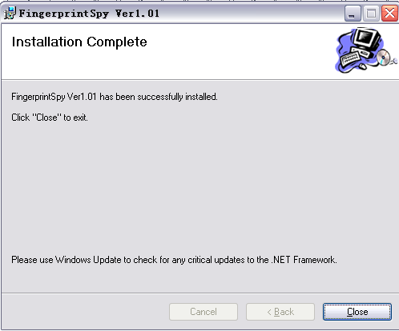
The installation complete window will be shown when installation finished. Click “Close” to exit installation.
- Function Instructions

- Enroll a fingerprint
- Click to select the fingerprint from the dialog widow.

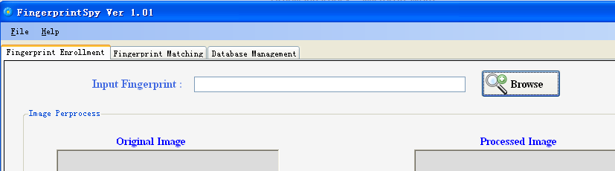
Click “Browse” to go to open file dialog.
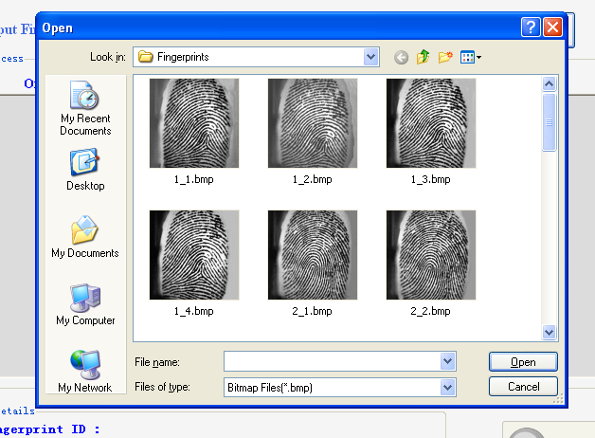
In the open file dialog, select a bitmap file from the list and click “Open” button to load the image.
Click “Open” to load the image
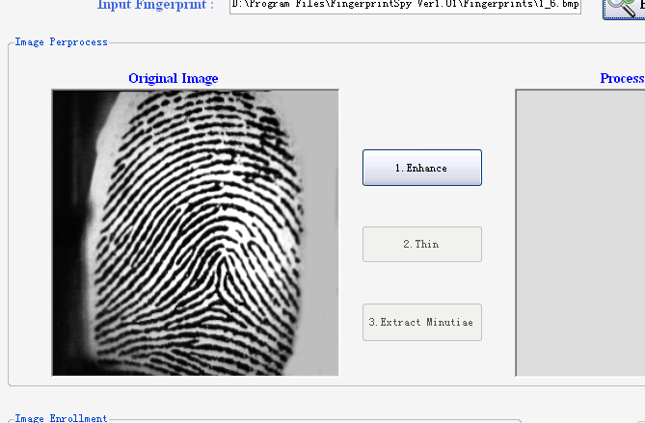
- After select the fingerprint image, the image will be shown in Original Image picture box and will be enabled. Click it to go to the next step – image enhancement.
The selected image will be shown
Click “1.Enhance” to enhance the image

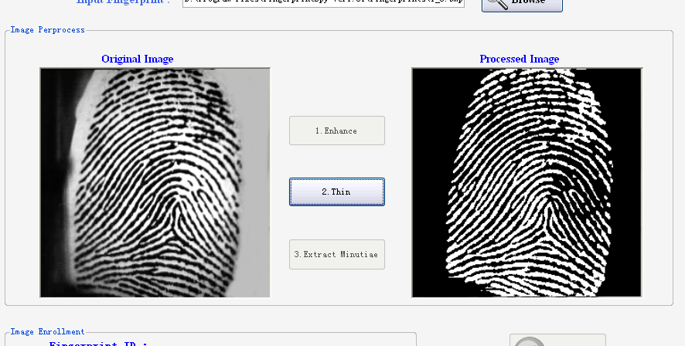
- The image will be enhanced and displayed in Processed Image picture box .Click”2. Thin” to go to the next step – image Thinning.
Click “2.Thin” to thin the image
The enhanced image will be shown.
- A message bar will be shown to tell the thinning is in process. After thinning, the thinned image will be shown in Processed Image and “3.Extract Minutiae” button becomes available. Click it to go to the next step – minutiae extraction.
The message bar will be shown.
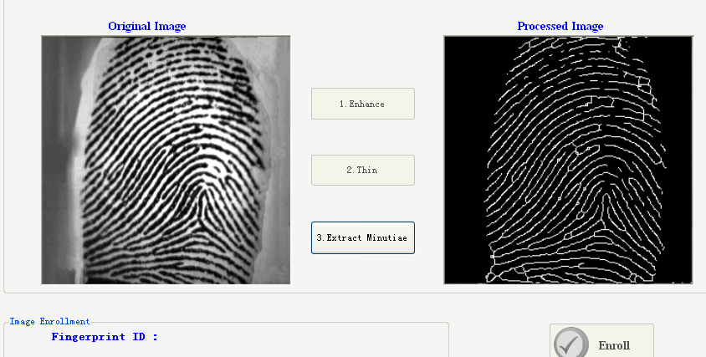
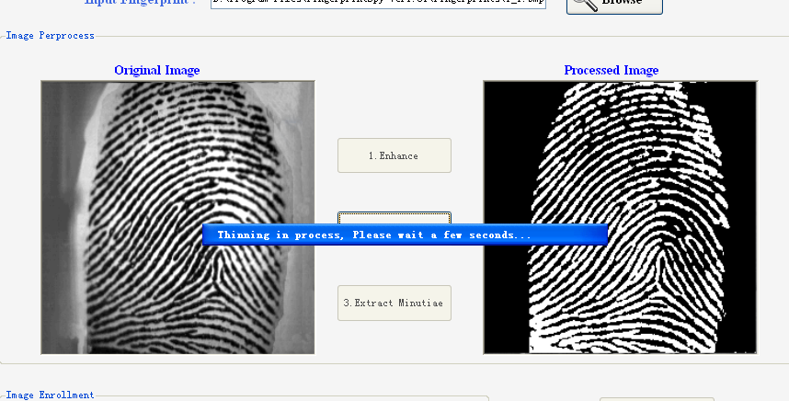
Click “3. Extract Minutiae” to go to next step

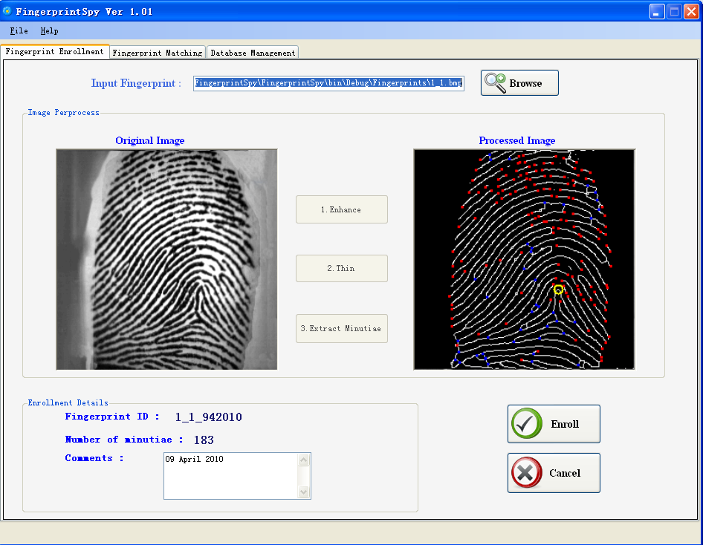
- After minutiae extraction, the result will be shown in the Processed Image box. Enrollment details will be displayed and will be enabled. Comment the fingerprint and click “Enroll” button to enroll the fingerprint image.
Fingerprint ID and no of minutiae will be displayed.
Click “Enroll” to enroll the fingerprint.
If success, a message box will be shown to tell so. If the fingerprint is already been enrolled, a failed message box will be displayed. Please note that one fingerprint can only be enrolled once in one day.

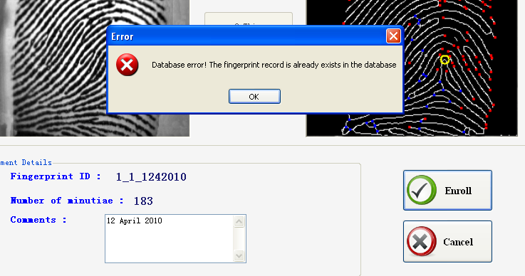
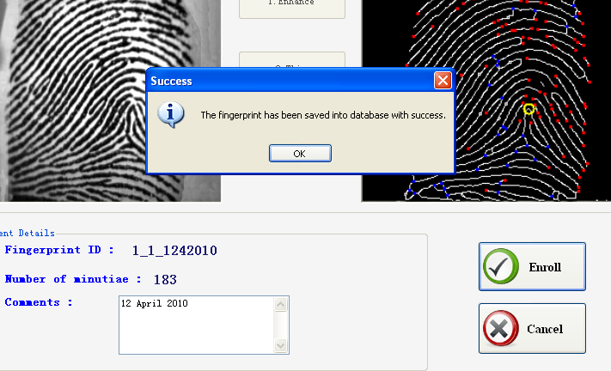
Message box shows success
Message box shows failure

- Match two enrolled fingerprints
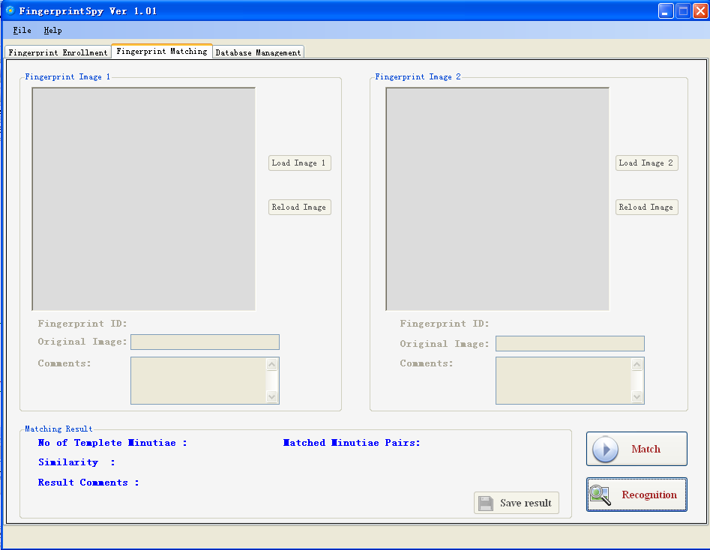
- Click to enable components used to match enrolled fingerprints.
Click “Match” button to enable GUI components used to match.
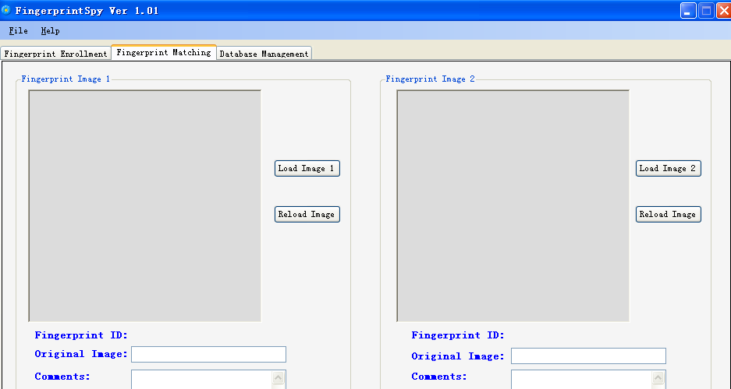
Components used to show details of enrolled fingerprints are also enabled
Load\reload image buttons will be enabled

- Click “Load Image 1” (or “Load Image 2”) to select the first enrolled fingerprint from database.
Click “Load Image 1” (or”Load Image 2”) button to select an enrolled fingerprint.
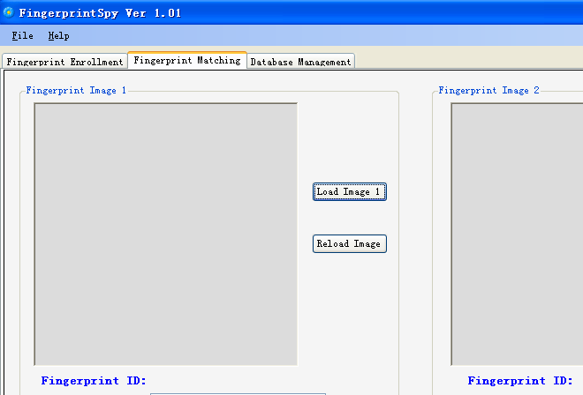
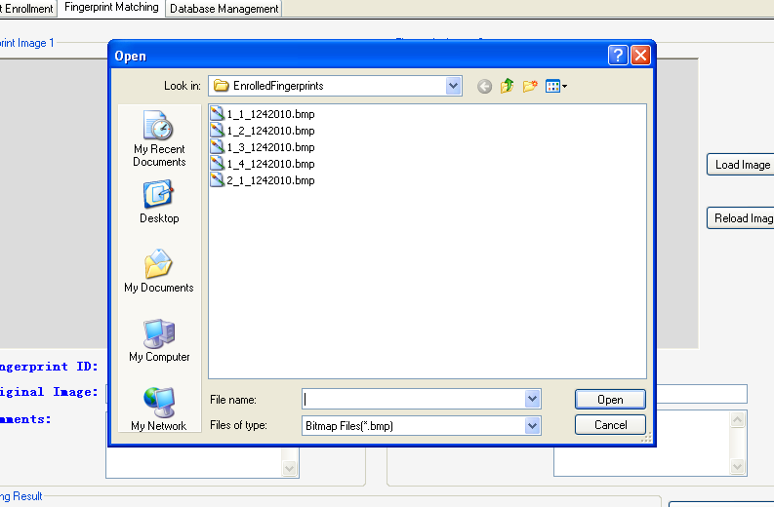
Click “Open” to load the image

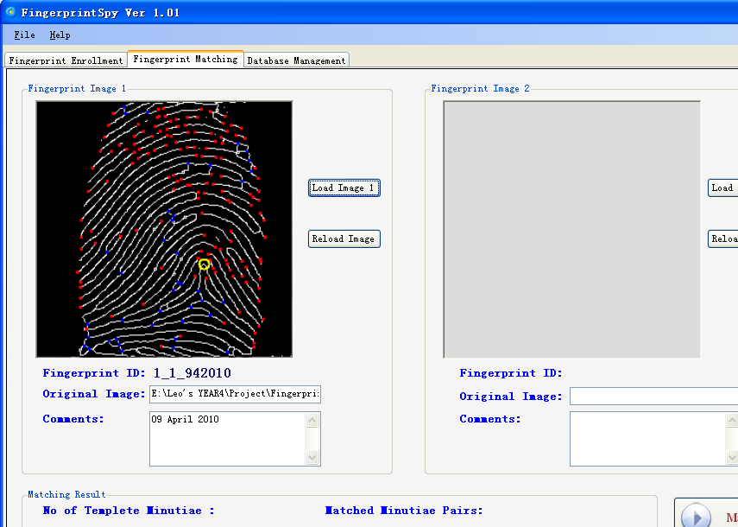
The selected fingerprint record and its relevant details will be displayed.

- Repeat step 2, Click “Load image 2” (or “Load image 1” – no sequence required) to select the other enrolled fingerprint.
After both enrolled fingerprints are loaded, the match function will start automatically to find the similarity of these two fingerprints.

- The detailed matching result will be displayed.
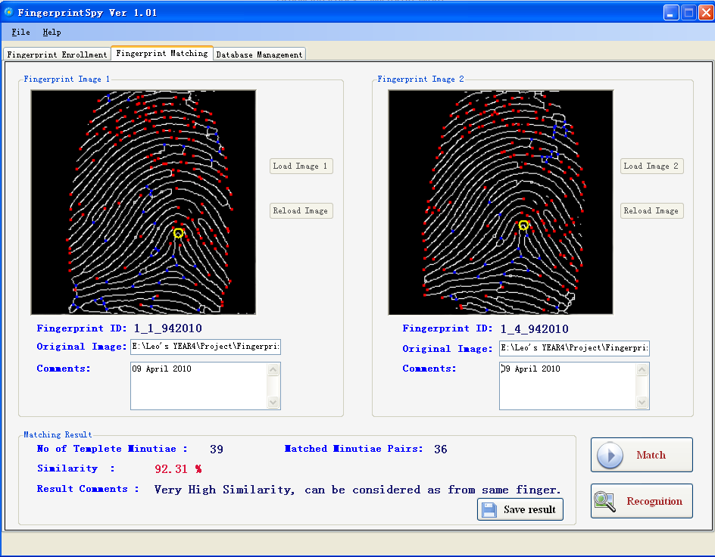
The enabledbutton allows user to save the matching result.
Click to save matching result
Matching result will be displayed

- Recognize an unenrolled fingerprint

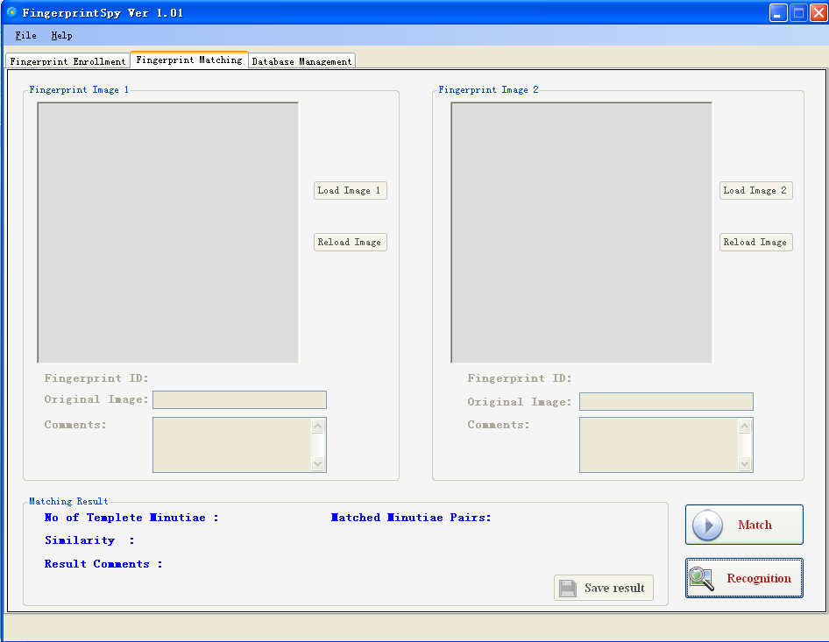
- Click to select an unenrolled (unprocessed) fingerprint.
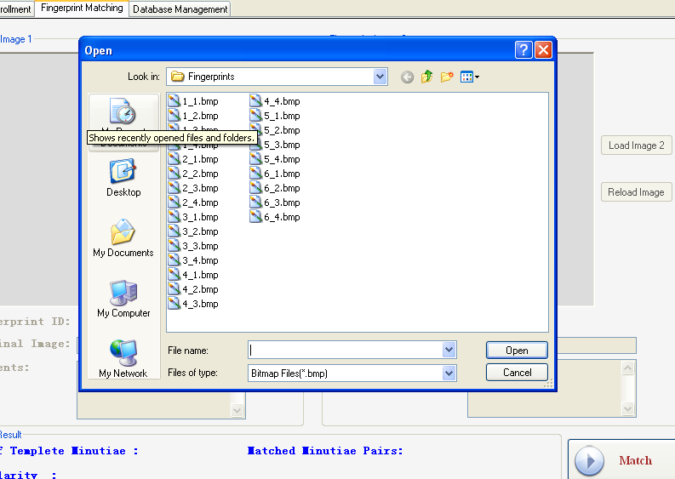
Click “Recognition” button to select an unprocessed fingerprint
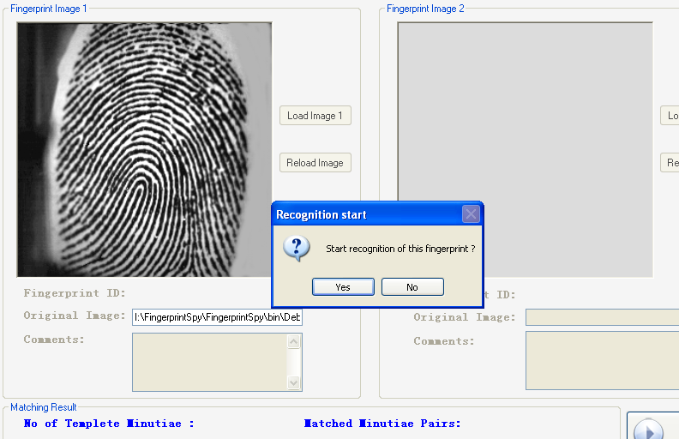
- After select a fingerprint, the selected fingerprint will be displayed in the “Fingerprint Image 1” box. A message box is shown ask for confirmation.
The selected fingerprint will be displayed

Message box ask for confirmation

- The recognition function will start automatically to search the database to find a matched fingerprint (or the enrolled fingerprint with the highest matching score) after “Yes” button clicked. The result of the recognition will be displayed.

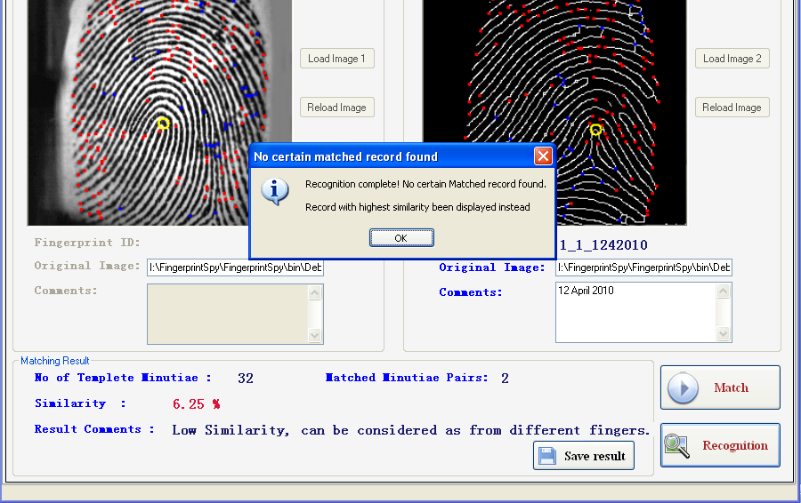
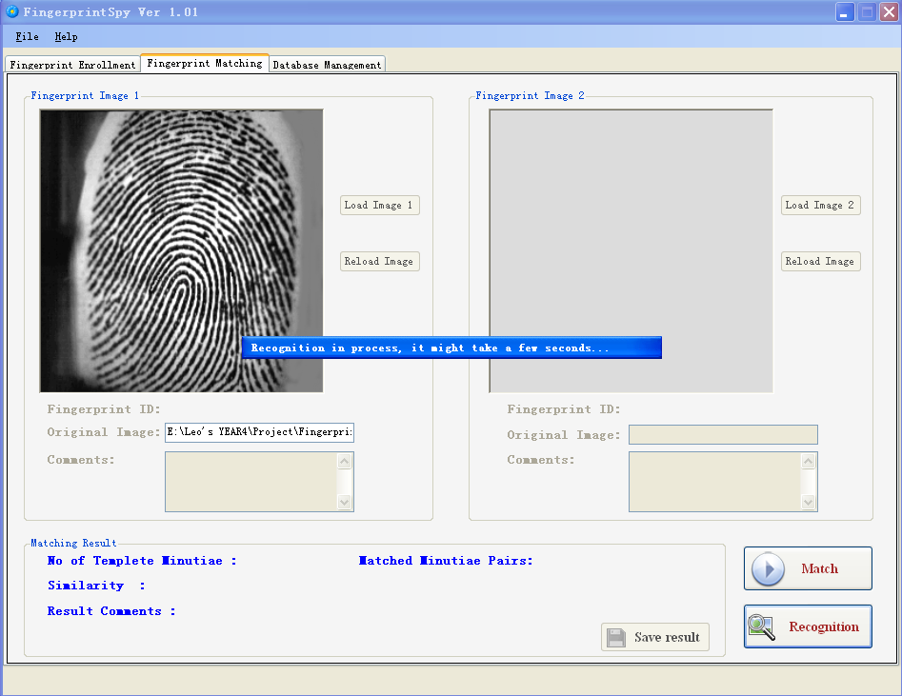
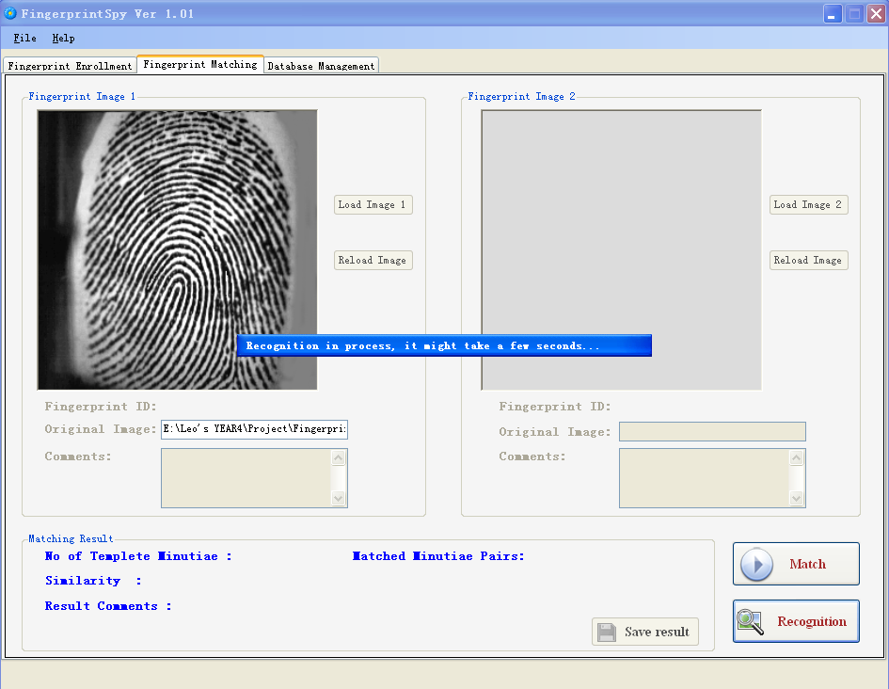
The message bar will be shown.
Recognition detailed result
Save result button
Result fingerprint and its details will be displayed
The message box shows recognition complete
- Save matching/recognition result

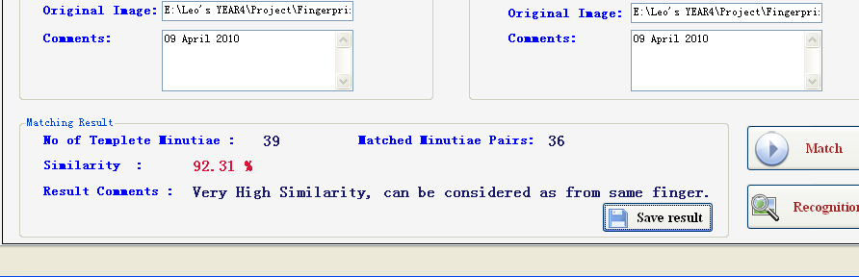
- After matching/recognition result be shown, the will be enabled. Click it to save the result.
Click to save the result

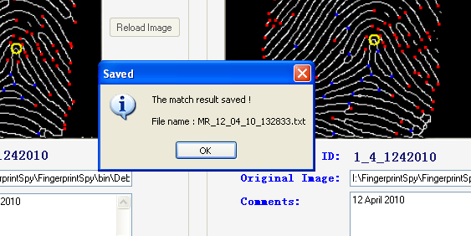
- A message box be displayed to shows the result been saved and the name of save file (*.txt)
Saved message box

- Manage enrolled fingerprint records

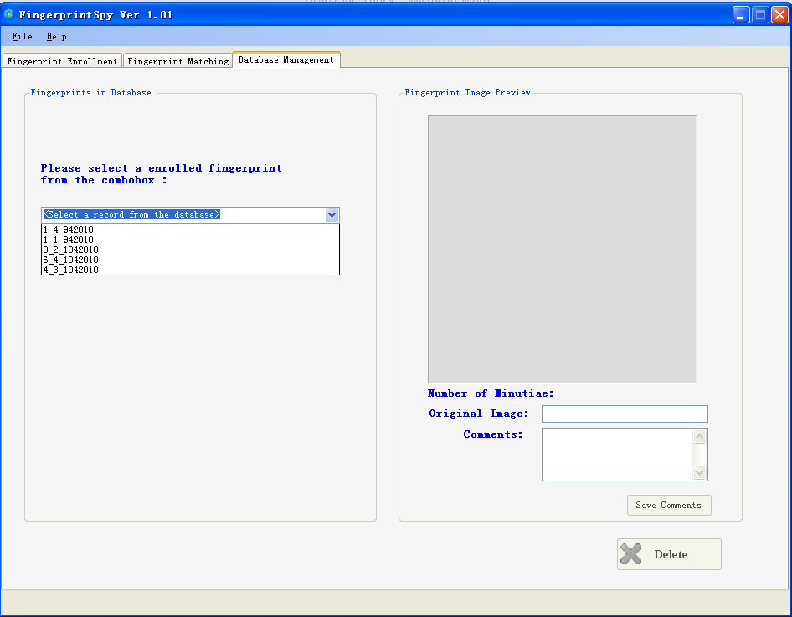
- The combo box on the left contains call enrolled fingerprint records. Select a record from the list. The enrolled fingerprint record will be shown on the left and , buttons will be enabled.

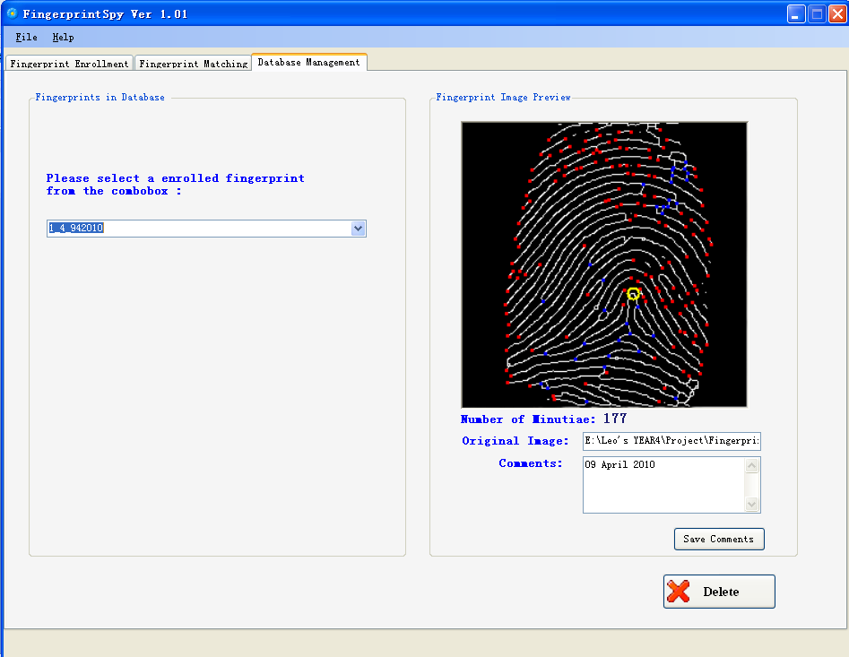
Buttons will be enabled.
Enrolled fingerprint and its details will be shown.

- To delete a recode, Click . A message box ask for confirmation will be shown. Click “Yes” to confirm.

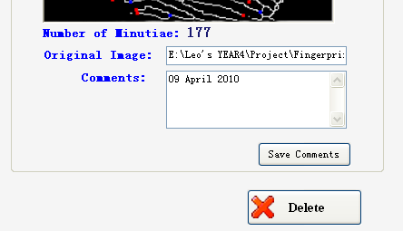

Click to delete the selected record.

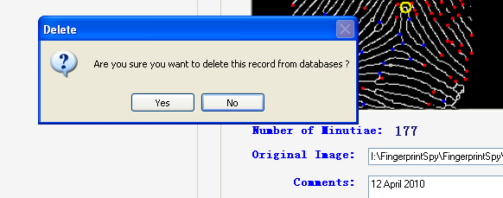
Click “Yes” to confirm deletion.

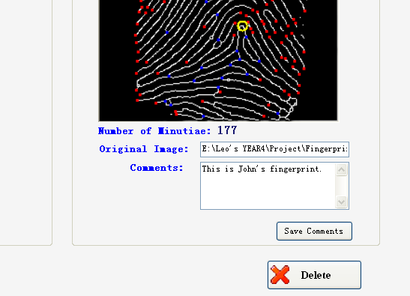
- To save the changed comments, click”Save Comments” button after input comments. Success message will be shown if saving success.
Click to save the new comments.
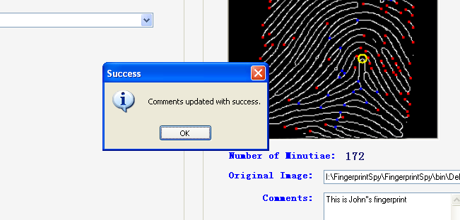
Success massage box

- Check project “About” information

To check application’s “About” information, click “About” menu item on the menu bar under the “Help”.
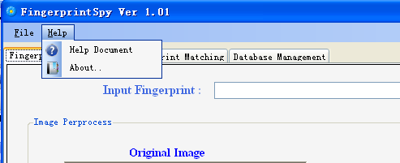

Click here to show “About” information.

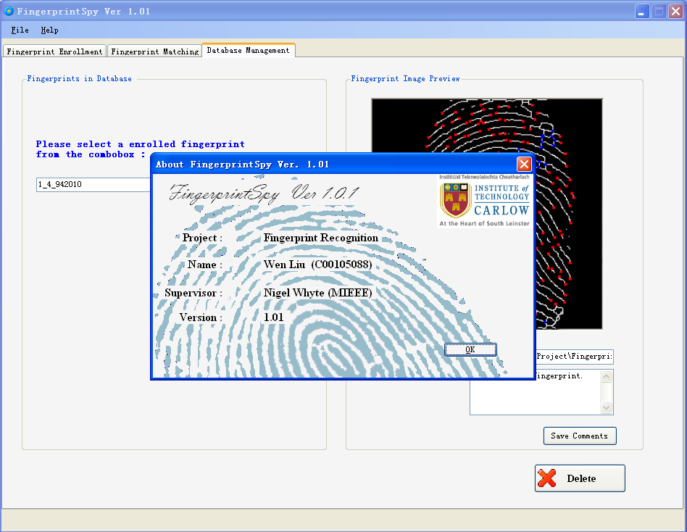

- Read application Help document
To read application’s help document, click “Help Document” menu item on the menu bar under the “Help”.

Click here to read help document.

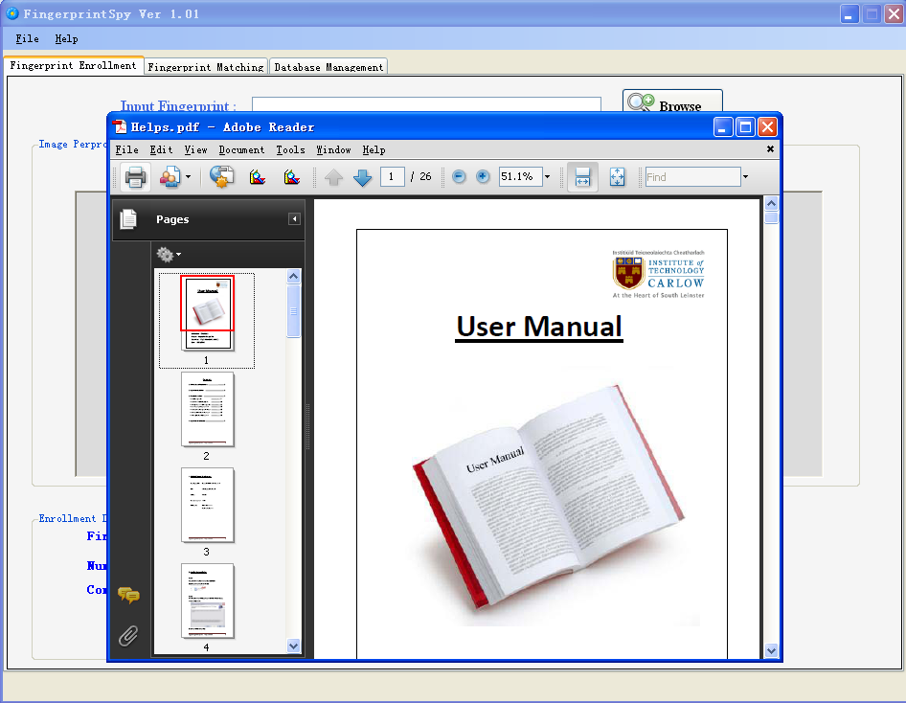

- Application Uninstallation

Step 1:
Click “Uninstall.exe” from Windows “Start” under “FingerprintSpy Ver1.01” item.
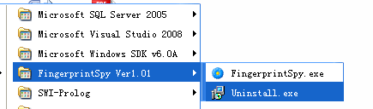

Step 2:
Click “Yes” to confirm uninstallation. The process box shows the uninstall process. Click “Cancel” button if want to abort uninstallation.
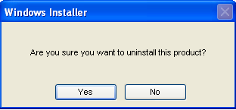

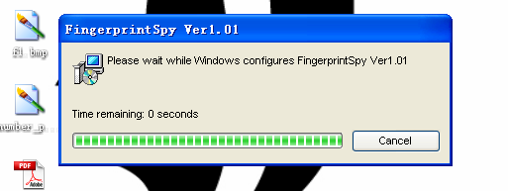

Click here to abort.

