Introduction

The Mobile Caring web app allows you to communicate with other carers, record patient weight readings and view notes and view past readings. The aim of the application is to help improve the organisation of the care you provide and also improve the communication between multiple carers.

Imagine you are taking care of your grandmother two days of the week while the next door neighbour cares for your grandmother on the other five days. It’s important to you that you can stay in the loop during the five days you are not caring for her. With the Mobile Caring web app you can easily stay up to date on any important developments and share information with the neighbour who is caring for your grandmother.

The Caring web app can be found by entering: http://caringapp.appspot.com in your browsers’ address bar.

Main Features

Login & Signup
The Caring App allows for the creation of carer accounts. It is necessary to sign up before you can start using the app.

Create Notes
The Caring App allows you to save notes to the system for other related carers to see. It also records the time and date of the note creation.

Create Weight Reading
The Caring App allows you to create weight readings based on the records you have taken from the patient.

View Note History
The Caring App keeps a record of all notes ever posted to the system. They can be read again at any time.

View Readings History
The Caring App creates a graph based on the weight reading data you have created.

System Requirements

Installation
The Caring App is based on Google App Engine and does not need to be installed locally. An internet connection is required.

The app can be accessed using a mobile device (Android specifically) or a non-mobile device. The graphical interface will change depending on the device you are using in order to offer the best experience.

Browser Compatibilities
Google Chrome (Version 26.0.1410.64) (Recommended for best experience)
Android Browser (Version 2.1)
Firefox (Version 15.0)
Opera (Version 12.15)
Internet Explorer (Version 9.0.8112.16421) (Partial, not recommended for best experience)

Login Screen

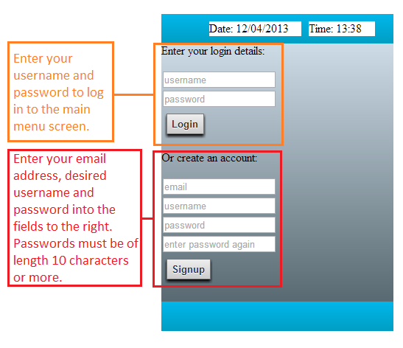

Main Menu Screen

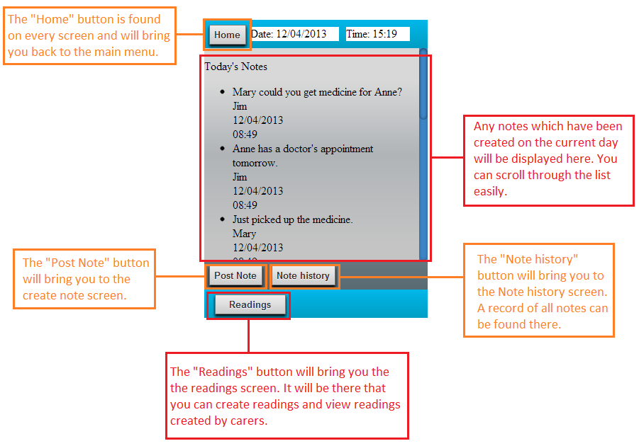

Create Note Screen

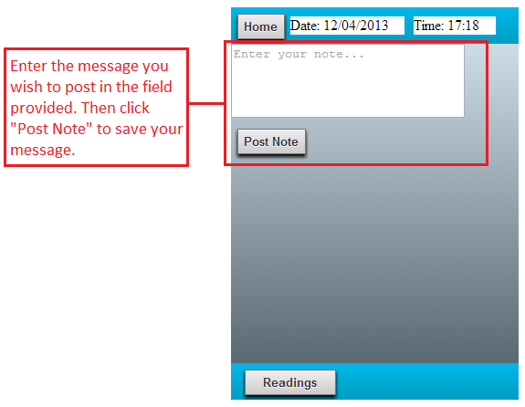

Note History Screen

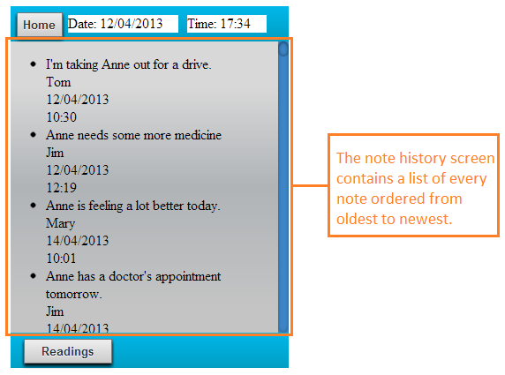

Readings Menu Screen

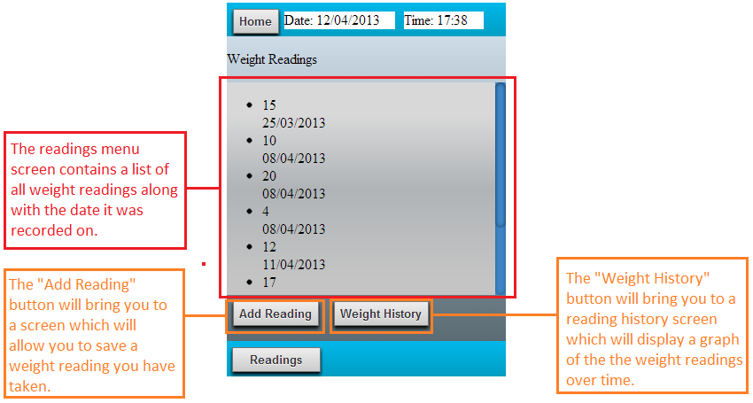

Create Reading Screen

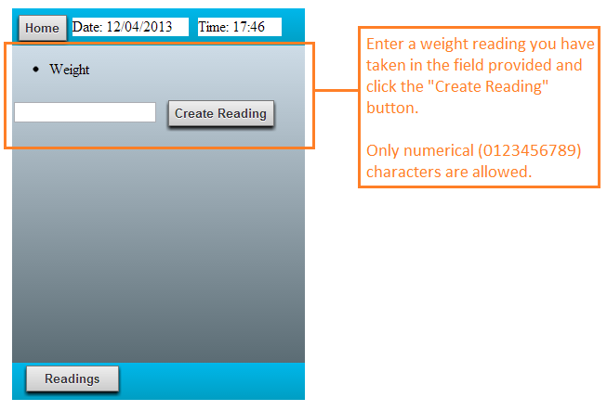

Reading History (graph) screen

