Project Mission

To create a mobile app that can assist in the care of a patient by storing important information relating to the patient on the cloud (online database) and allowing the synchronization of this information between carers. The app will store information regarding the patients’ health statistics, readings taken, medicine schedule and their appointment schedule. The app will also store notes for communication between carers.

Feature Summary

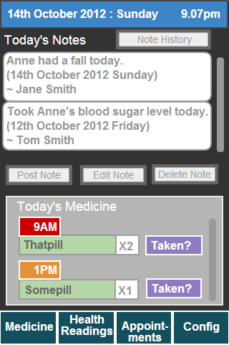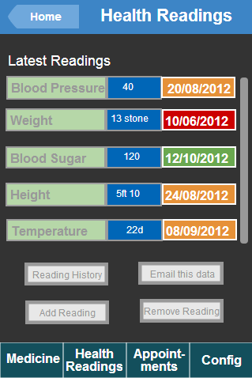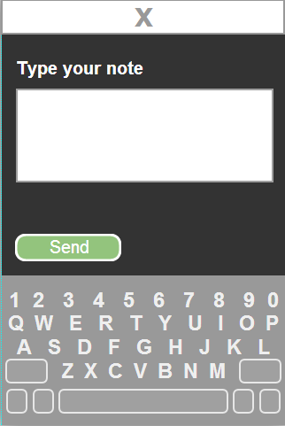

- View notes posted on the current day and the day’s medicine requirements on the main screen.
- Post and update notes to the app.
- Create and edit Health statistics. (Blood Pressure, Weight)
- Create and edit readings of Health statistics.
- Create and edit appointments.
- Manage user app privileges.
- Change the app view for a patient user.
- View the history of all notes, readings and medicine logged on the app.

Targeted Users & Benefits

Primary
The app is mainly targeted towards people who are responsible for the care of another person. This could potentially be a family member, a family friend or a health care professional.

Secondary
The app is secondarily targeted towards the patients themselves, regardless of their level of ability with technology.

Benefits
This app will bring many benefits to both carers and those being cared for such as:

- Increased and easier communication between multiple carers.
- Various important information about the patient, all in one place
- Carers can easily stay up to date with any changes in the patient.
- Carers and Patient receive reminders for the day’s scheduled medicine and appointments.
- Can help patients stay more independent.
- Information displayed in a concise, non-cluttered manner.

Key Factors used to judge quality:

- The interface should be clear and usable by all skill levels.
- The app should allow the user to create, edit, view and delete various aspects of the app. Such as notes, readings, health statistics and appointments.

Crucial product factors:
- Must be compatible with a variety of different screen sizes.
- Information stored on the database must be highly secure.

