Introduction

The following research was carried out in order to get a better understanding of the necessary functionality and GUI for an app designed to store patient information and allow the sharing of information between carers.

Research was also carried out on the choice between Native and HTML5 development, stating the benefits and disadvantages of both.

We will also look at the cloud and the storage of data on the cloud in order to get an understanding of what the best cloud option for the caring app would be.

Finally we take a look at the legal and social implications that would occur from such an app.

Similar Apps

In order to get a better understanding of the necessary functionality and GUI layout of this project I researched similar apps currently available. In the following section each of these apps are detailed based on general information about the apps, my own thoughts about the apps and also the technology used in the creation and maintenance of these apps.

Memotouch

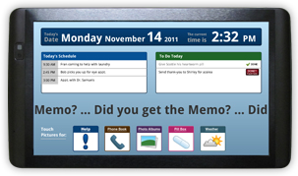

Memotouch [MEM10] is an app created with Alzheimer patients in mind. Users receive a tablet (based on Archos technology) that comes with memotouch installed. The best part of this app was how customizable the interface was for patient use and that the interface also offers a lot of useful information without feeling cluttered. Memotouch allows carers to customize the interface and functionality a patient has access to, depending on the patient’s ability with technology.

Patients also have easy access to help thanks to the option to send emails or texts to carers. Another aspect of the app that I felt was very useful was a phone book that contained all carer phone numbers along with emergency numbers. One side of the app that was not very good was that medicine notices were mixed in with other to-do items on the main screen and the urgency of to-do items was not immediately obvious.

The carer side of the app is web based. Unfortunately I was unable to learn what kind of cloud service Memo Touch uses. I was unable to find detailed technical information about this app, either on the apps website or in reviews about the app.

Out of all the apps that I have researched I felt that Memotouch was the most relevant to what I am attempting to do with this project.

Pillboxie

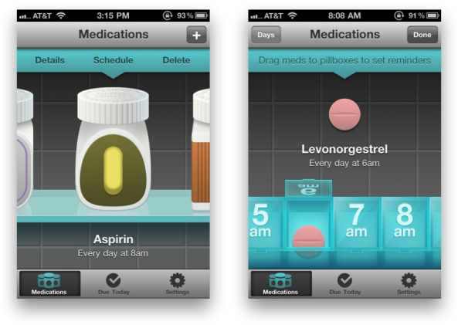

Pillboxie [PIL11] is an IOS app that is focused on helping the user to organise their medicine in a very visual and appealing way. The app represents a medicine cabinet and actions such as adding medicine dosages to a particular time is as simple as dragging the medicine into a tab for that time. I really liked how user friendly and customizable this app was. I also thought it was interesting how the user could input how they felt after taking the medicine.

On screens where data must be entered there is a maximum of two clicks necessary. Another negative was that there was no option to input dosage amounts for medicine to take. I also felt that the app although useful as reminder app could be too restrictive for some users.

Pillboxie is an app native to IOS and all data is stored on the user’s phone. This means that the app does not require a network connection. However a feature in the latest update allows users to search for the lowest price on the medicine they are taking.

Unfortunately I was unable to try out Pillboxie myself. I instead watched videos of the app being used.

eCaring

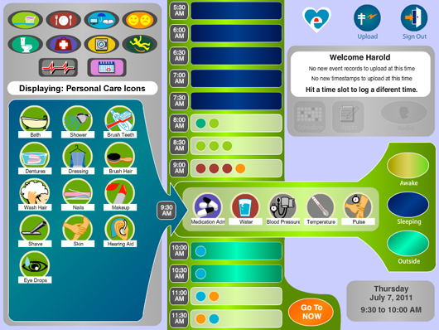

eCaring [CAR00] is an application intended for families and carers who have a patient to care for. It is a web based app and they do not provide an app designed for patient use. Although my first impression was good I felt that the app was too cluttered and could possibly be too technical for some users. This app also stores more information about the patient than the other apps that I have researched, including information about meal times and hygiene amongst others.

The app also contains detailed charts and graphs relating to a patient’s health which while I felt was very useful would be far too complicated and unsuitable for the app I am creating.

When I tried this app for the first time I discovered that this app was very cumbersome. In order to select a particular time you must first click through every single time slot until you reach the required time slot. The app also allows conflicting statuses to be included which I felt was very odd. For example it is possible to input that a patient ate their meal and also refused their meal on the same time slot.

iHealth MyVitals

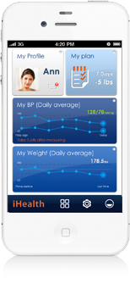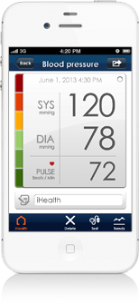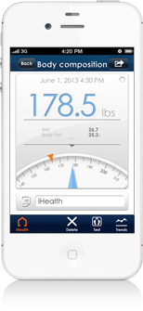
The iHealth MyVitals [IHE10] app for the IOS platform allows the user to record health readings. The user can use the iHealth body analysis scale in order to record their weight or they can use the iHealth blood pressure monitor to take and record their blood pressure level.

Using the iHealth scales this app allows the user to record various readings such as body fat, bone mass and daily calorie intake while the iHealth Blood Pressure Monitor part of the app is intended to take the users blood pressure and allow the user to view detailed graphs and monitor their blood pressure in real time. The app works alongside a blood pressure monitor dock to take the users blood pressure.

The user can also set reminders to take medicine, readings and exercise.

The app has a very visually appealing and easy to use interface. It was also very responsive. The readings it takes are reasonably accurate. I thought the information it provided was quite detailed and useful. I felt the layout of the app was organised very well and even on first use it felt very intuitive.

Users are able to upload their readings to the iHealth cloud and these readings can be accessed and shared (with friends) through the iHealth website. I emailed iHealth to ask them about the cloud technology they used however they did not respond.

GUI Mockups

During my research I created a mock GUI example of the caring app using FluidUI. The following are a few examples of the various screens that will be part of the app.

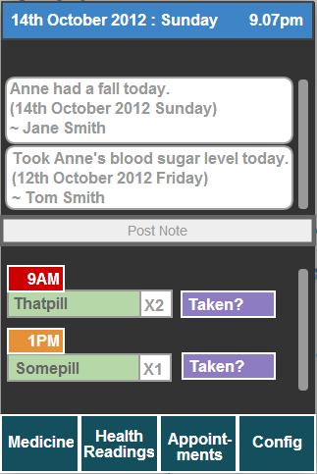
Example GUI of the main screen for the caring app.
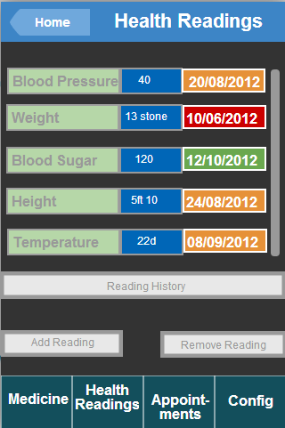
Example of the Health Readings screen

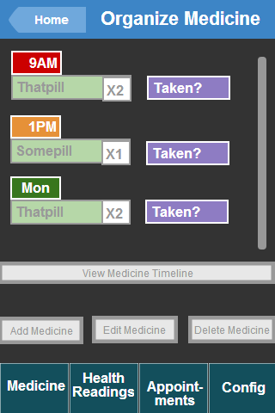
Example of the Organize Medicine screen

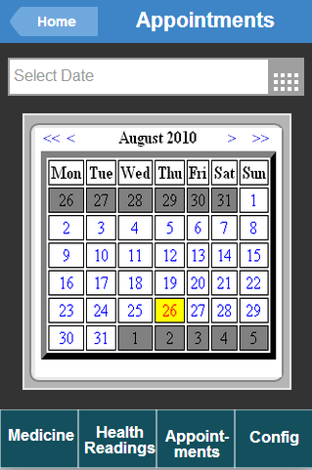
Example of the Appointments screen

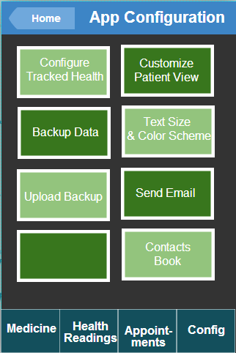
Example of the App Configuration screen

Platform Research
One of the most important decisions I will need to make for this project will be whether I choose to develop the app using HTML5 or develop the app natively. In order to make an informed decision on which choice would be the most appropriate for my project I have researched both of these possibilities, stating their advantages, disadvantages and how important these aspects will be for my project.

Native
Developing an app natively for a mobile os has the advantage of full access to the mobiles’ functions such as the camera and GPS. [SIX18] Native is generally faster than its HTML5 alternative as it directly communicates with the mobiles operating system. [TDK21] [APP23]

Native apps can also be used without a network connection. If your app is developed natively you also get the benefit of being able to sell your finished product in an app store. Native has the disadvantage of being platform dependent, a native is developed for a particular mobile platform and must be rewritten for any other mobile platforms required.

HTML5

One of the more obvious advantages to HTML5 is the platform independence it provides. Which for developers means that more users can be reached and the cost associated with the project is reduced. Unfortunately despite this benefit HTML5 is not entirely independent. Different types of browsers and different versions of these different browsers will interpret HTML5 differently. [APP23]

However HTML5 has a huge negative in that it is not as secure as native and information could be more easily intercepted or hacked. Both HTML5 and Native commonly use the Secure Socket Layer (SSL) protocol to protect their data during transit. [APP23]

Although web based apps generally require the user to have an internet connection, an increasing amount of these web based apps now include offline versions.

PhoneGap [PHO14] is an open source framework that provides developers with an environment to create HTML, CSS and Javascript apps and which can still call native device features and sensors via a common JS API. [AND15]

Platform Decision

As a result of my research I have decided that I will use HTML5 as the platform for the app I am creating. This is due to the platform independence it provides and due to my own interest in developing my HTML5 skills. The IDE that I will be using is Microsoft WebMatrix.

Cloud Storage Research

Cloud computing is used constantly in our everyday lives. If we have ever uploaded our data to another server then we have used cloud computing. As an example, we are using cloud computing if we upload a picture on Facebook. As the main purpose of the app I am creating is sharing information between carers, the cloud platform that I eventually choose is very important.

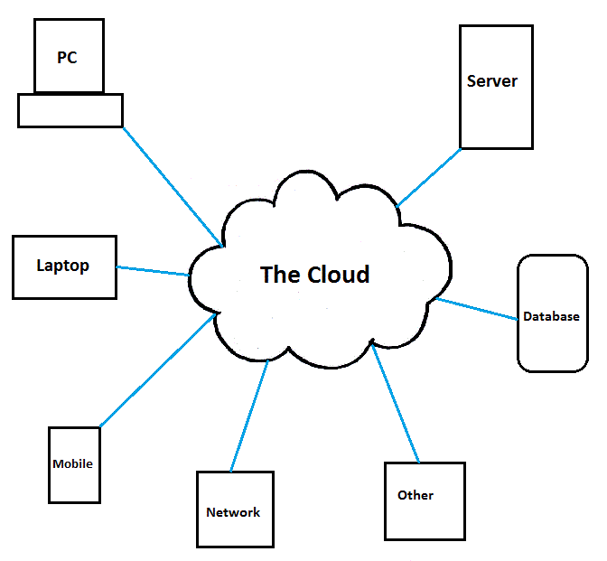

In this diagram the blue lines represent data travelling to and from the cloud.

Google App Engine
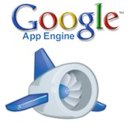
Google App Engine [GOO16] is a platform that is used to host web applications in data centres managed by Google. By using Google App Engine you allow Google to take care of hosting your application while you can focus solely on the application itself. It is known as “Platform as a service”.

In terms of security the service has received a SSAE-16 security certificate.

Amazon Web Services

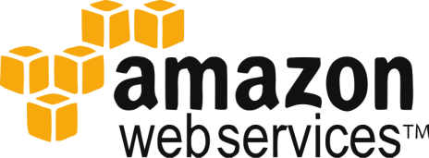

Amazon Web Services [AWS22] is a cloud computing platform which offers a selection of cloud infrastructure services. Amazon Web Services has received many security related certificates such as PCI DSS Level 1, ISO 27001, FISMA Moderate, HIPAA, and SAS 70 Type II.

Amazon Web Services offers a relational database on the cloud which has the benefit of automatic scaling.

SpiderOak

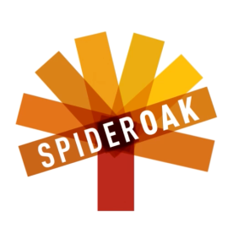

SpiderOak [SPI17] was one of the first cloud services that I came across in my research. I became interested in it due to it being a zero knowledge encrypted cloud data storage service and thus it initially seemed like the perfect candidate for an app that relied heavily on the security of its information. However I came to the conclusion that it would probably not suit the needs of my project and that a ‘Database as a service’ cloud provider would be a better fit.

The service is known as zero knowledge because the only information SpiderOak are aware of is the amount of bytes your data takes up on their services, everything else is encrypted and your password is not stored on their server. They have no way to decrypt your data. (As encrypting and decrypting is done on the user end) So even if they were to receive a warrant to access your data they would be unable to.

Salesforce database.com

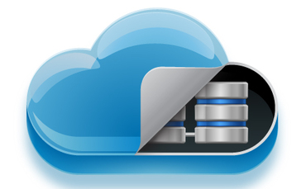

Database.com [DAT19] was a cloud service I discovered after researching database as a service. Database.com can be accessed through any language, any device or any platform through standards based APIs. As a “database as a service” provider, the service offers an already created database which requires little maintenance on the side of the user. It offers the huge advantage of not having to “do it yourself” and build your own database on the cloud.

Xeround

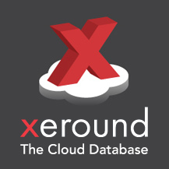

Xeround [XER20] is another “Database as a service” cloud provider I found through my research. The database they provide can be hosted on other cloud based services such as Amazon Web Services. It offers MySQL as a service on the cloud.

In their privacy policy they state that while they have employed measures to protect your data from unauthorized access they cannot guarantee the safety of your data.

Cloud Technology Decision

I have decided to use Google App Engine for my projects cloud technology. I have decided this because I felt it was the most versatile and unrestrictive of the cloud technologies I have researched.

Legality Research

The legality of storing a patient’s health information on the cloud is questionable. Most cloud services I have researched have a clause stating they will not be held liable for the loss of data on the cloud. Alongside this many cloud services may be required by law to pass along information to authorities even if the content is only suspected of being illegal. [ECO24]

The lack of control over how your data is processed on the cloud is extremely dangerous to the privacy of patients. There is also a lack of control over how and where the patient’s data travels before it reaches carers from the cloud. There is a lot of ambiguity concerning who can access your stored data and for what reasons. There is also the possibility that the cloud service that you are using will go out of business and your data may or may not be returned to you as a result. As a patient’s data may be stored on a server anywhere in the world, it can add more complications to legal proceedings as different countries will obviously have differing laws related to the Cloud.

As an example the USA Patriot Act passed in 2001 as a response to the 9/11 terrorist attacks, allows the US government simplified access to any data stored on the cloud deemed to be suspicious. [MAY25] Many other countries across the world have similar laws in place. The Mutual Legal Assistance Treaties (MLATs) allow US and EU member states access to data on servers located in any country that is part of the MLATs. [ECO24]

References

[MEM10] Memo Touch (2010), A New Era In Alzheimer Products & Dementia Products, Memo Touch LLC, Available at: http://memotouch.com/
[Accessed Nov 07 2012].

[PIL11] Jared Sinclair (2011), The easy way to remember your meds | Medication reminder for iPhone and iPod Touch, Available at: http://www.pillboxie.com/
[Accessed Nov 07 2012]

[CAR00] eCaring (2000), Better lives through better care, Available at: http://ecaring.com/
[Accessed on Nov 07 2012]

[IHE10] iHealth, Put your health front and centre with iHealth mobile products,
Available at: http://www.ihealthlabs.com/ihealth_myvitals_app.htm
[Accessed on Nov 7 2012]

[AND15] Andre Charland, Brian Leroux, Mobile application development: web vs. native,
Available at: http://queue.acm.org/detail.cfm?id=1941504
[Accessed on Nov 10 2012]

[PHO14] PhoneGap, Available at: http://phonegap.com/
[Accessed on Nov 10 2012]

[GOO16] Google App Engine, Available at: https://developers.google.com/appengine/
[Accessed on Nov 10 2012]

[SPI17] SpiderOak, Available at: https://spideroak.com/about/
[Accessed on Nov 10 2012]

[SIX18] Six Revisions, JT Mudge, Native App vs. Mobile Web App: A quick comparison,
Available at: http://sixrevisions.com/mobile/native-app-vs-mobile-web-app-comparison/
[Accessed on Nov 10 2012]

[DAT19] Salesforce database.com, Available at: http://www.database.com/
[Accessed on Nov 11 2012]

[XER20] Xeround, Available at: http://xeround.com/
[Accessed on Nov 11 2012]

[TDK21] TDK technologies, Mobile Development – Web, Hybrid or Native?
Available at: http://www.tdktech.com/mobile-app-platforms
[Accessed on Nov 11 2012]

[AWS22] Amazon Web Services, What is AWS?,
Available at: http://aws.amazon.com/what-is-aws/
[Accessed on Nov 12 2012]

[APP23] Appcelerator, Native vs. HTML5 Mobile App Development Which option is best?,
Available at: http://resources.idgenterprise.com/original/AST-0075634_appcelerator-whitepaper-native-html5-7.pdf,
[Accessed on Nov 12 2012]

[ECO24] Ecommerce Times, The Cloud Privacy Illusion,
Available at: http://www.ecommercetimes.com/story/75848.html,
[Accessed on Nov 15 2012]

[MAY25] Mayor Brown, The USA Patriot Act and the Privacy of Data Stored in the cloud,
Available at: http://www.mayerbrown.com/publications/the-usa-patriot-act-and-the-privacy-of-data-stored-in-the-cloud-01-18-2012/,
[Accessed on Nov 15 2012]

