AUTOMATIC LICENCE PLATE RECOGNITION PROJECT PLAN
By
Anthony Tierney

AUTOMATIC LICENCE PLATE RECOGNITION PROJECT PLAN
Anthony Tierney
I.T. Carlow, Kilkenny Road, Carlow
22-Nov-13

Table of Contents
1. Introduction 1
1.1. Purpose 1
1.2. Scope 1
1.3. Intended Audience 1
2. Overview 2
3. Goals and Scope 2
3.1. Goals 2
3.2. Scope 3
3.2.1. Included 3
3.2.2. Excluded 3
4. Schedule 4
5. Timeline 5

Introduction

Purpose
The aim of this document is to outline the project plan. It will detail the gaols and scope, any organisations involved, the schedule and budget, risk and delivery management and quality assurance.

Scope
This manual provides details of the project plan for the Automatic licence plate recognition project.

Intended Audience
This document is intended for those who wish to know the plan of the automatic licence plate recognition project.

Overview
The motivation for this project is to create a viable alternative to car park management companies. The aim is to create a solution that is more attractive to these companies that wish to save time and revenue by speeding up the process of recognising vehicle licence plates. This will allow car park attendants to process more vehicles per hour than previously by manually entering the licence plate number.
The project that will be delivered will be a new product different from the conventional method of car park management. The project should take from the beginning of October 2013 to the 28th April 2014.

Goals and Scope

Goals
The main high priority goals of this project are as follows:
- Create an Android application that can recognise licence plates
- Create an online database that can store different car parks and vehicles associated with those car parks and car park attendants
- Allow the app to download the database table specific to the car parks needed
- Have a detection rate of at least 7 out of every 10 scans
- Create a solution that companies will find attractive and that may speed up operations
- Create a web based interface that allows the creation, reading, updating and deletion of car parks and vehicles
- Create a website that advertises the capabilities of the system
- Deliver the project either on time or early
- To have the documentation detailed and accurate so that the system may be ported to a different platform (for example; iOS or Windows Phone).
- Complete substantial unit testing
Additional lower priority goals that may be met on completion of the main goals:
- Attractive user interface
- Built in tips to enhance the accuracy of the scan
- A fully fledged web user interface that is easy to use and contains additional help and frequently asked questions sections

Scope

Included
Below is the list of deliverable and a description and delivery date of each:
Deliverable | Date | Description
Research Manual | 22nd November 2013 | A document containing the research relevant to the project
Project Plan | 13th November 2013 | A description of the project plan
Functional Specification | 13th November 2013 | Description of the behaviour of the system
Design Manual | 10th January 2014 | Detailed description of the design of the project, its functionality and its classes
User Manual | 28th April 2014 | A manual that describes how the system works for users
Project Report | 28th April 2014 | A report on the project; what was implemented, what wasn’t; what would be different next time.
Code Listings | 28th April 2014 | A listing and description of the project’s code.

Excluded
This project will exclude the following features:
- Users will not be formally trained to use this system
- The system will not automatically detect a vehicle entering the view of the camera
- The system will not offer an unlimited allowance of database entries
  - This will be subject to the allowances of the cloud storage platform

Schedule
Deliverable | Date
Research Manual | 22nd November 2013
Project Plan | 13th December 2013
Functional Specification | 13th December 2013
Design Manual | 10th January 2014
Web Page | 10th January 2014
First project presentation | 24th January 2014
Final project presentation | TBA
Industery Demo | TBA
User Manual | 28th April 2014
Project Report | 28th April 2014
Code Listings | 28th April 2014
Project Code Submission | 28th April 2014
Project Demo | 30th April 2014

Timeline
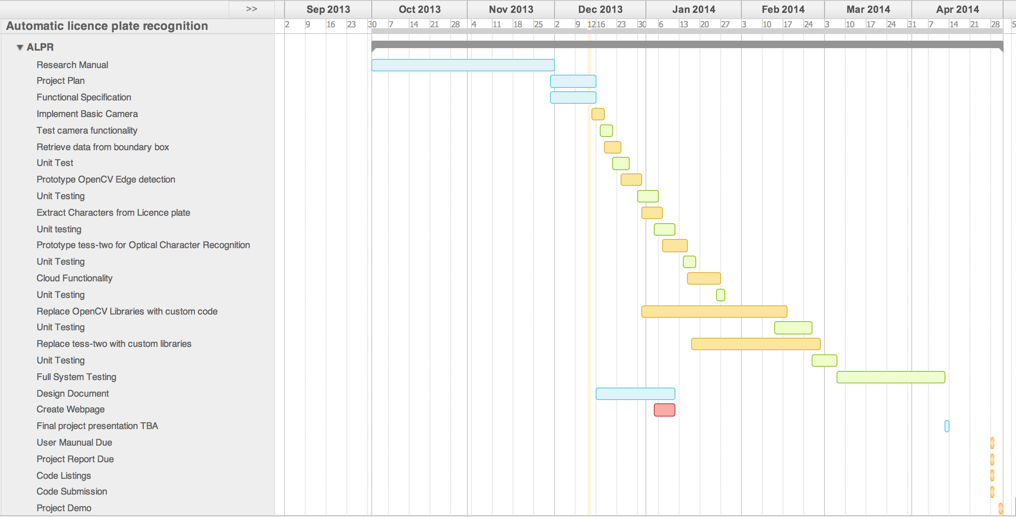

Description of Tasks
- Implement Basic Camera
In this phase the skeleton application is created that captures and stores an image retrieved from the camera. This is performed on the android device
- Retrieve data from boundary box
Here, a boundary box is drawn on screen for the user to align the licence plate within this box to ensure accurate detection
- Prototype OpenCV Edge Detection
OpenCV libraries are implemented to allow the app to function (edge detection and noise filtering) while the custom code is being written.
- Extract characters from licence plate
Implement the algorithm to extract the characters from the licence plate
- Prototype tess-two for optical character recognition
Use the tess-two library to prototype the optical character recognition.
- Cloud Functionality
Implement the cloud functionality to allow the retrieval and storage of vehicle registration plate numbers.
- Replace OpenCV with custom code
Implement the code from the OpenCV libraries tailored to the app.
- Replace tess-two with custom code
Implement the code from the tess-two library tailored to the app.

