MOS Plugin

User Manual
Luca Venturelli 2013

Table of Contents

1. Getting Started 3
1.1 About 3
2. Using MOS Plugin 3
2.1 User Interface 3
2.2 Installation and setup 4

Getting Started

About
The aim of MOS Plugin is to offer a good instrument to analyse and verify the quality of an online game. The software developed implements a metric based on the E-Model used in VOIP to analyse the quality of a communication.
The metric presented analyses not only the network but also the hardware quality to obtain a more precise model for the perceived game quality.

Using MOS Plugin

User Interface
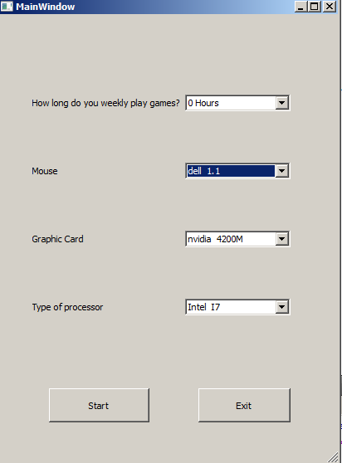
Figure 1 MOS User Interface
- MOS Plugin Contains 4 information to choose:
- The number of hours the game has been played;
- The Mouse used;
- The graphic card;
- The type of processor.
The main GUI contains also two buttons, the first closes the application and the second starts the network analysis.
- Once pressed the Start button a login form (Figure 2) allows the user to insert username and password to start the analysis of the network.

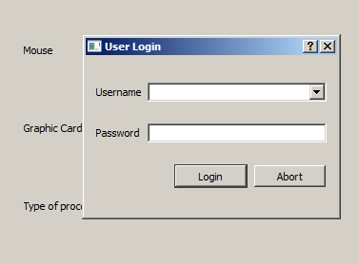
Figure 2 MOS Login interface

- The process will then run in background and can be managed by a tray icon.

Installation and setup
To install the program simply unzip the program in the folder you prefer and simply run it. The program has to connect to a server in order to work. You can set up your own server or connect to our server at the ip 149.153.4.27. To setup your own server you need to follow those instructions:
- Install the database postgresql.
- Create a new user for your database.
- Use the sql code provided with the program to create the table
- Populate the table with the data and the values you want to use according to the specifications.
- Setup IP Address, username, password and database name chosen to connect to the database.
- Start the application.
- Choose the hardware of your machine from the list displayed.
- Login with the username and password of your account.
- Play your favourite game and have fun.

